TRAIL ASSESSMENT FORM

Doc. # | 1012 | Trail Name |  |  | Breakneck Ledge Path North | Trail Type: |  | Wide - M | Condition |  | Good
Route: |  |  | Wolcott Path – 1160 – 1162 – 1178 – 1180 – 1204 – 1203 – Chestnut Run Path
Recent Weather: |  |  | Warm - melting snow and ice – Snow cover on trail was 0-3 inches
TRAIL LANDMARKS |  |  | - Trailhead is located off of Wolcott Path, .3 miles west of the Wolcott Path fire gate adjacent to Reservation Headquarters.  - Trail leave on the right side of Wolcott Path at trail intersection marker 1160.  - Trail blazed with rectangular yellow and triangular yellow direction blazes as noted on map.  - Hancock Hill path leaves on right at 20 feet.  - Overhead bn at 30 feet.  - Wb running L to R at 200 feet. Submerged wood. Dt on R needs cleaning.  - Rd running L to R at 266 feet. Dt on R with lbd in dt blocking flow. Remove. (1)  - Ledge wb running L to R at 367 feet. Dt on right needs cleaning.  - Skyline North trail crosses at intersection marker 1162 at .1 miles.  - Rd running L to R at .17 miles. Dt on right into rkw. Needs cleaning.  - Trail opens up to road width at .17 miles.  - Hemenway Hill Path enters on left at intersection marker 1178 at .38 miles.  - Unnamed path crosses north/south at intersection marker 1180 at .41 miles.  - Three cv under road running R to L at .44 miles. Large dt on right feeding all inlets. 10”, 13”, 10’ plastic pipe. Well maintained rkw on both sides. Outlets and inlets require cleaning. Inlets full of leaves.  - Wooden (log) wb running R to L at .53 miles. Dt on R and L. Needs cleaning.  - Rd running R to L at .58 miles. Dt on left. Needs cleaning.  - Rd running R to L at .60 miles. Dt on left. Needs cleaning.  - Lbd 8” across trail. Remove. (2) (see photo below)  - Hancock Hill Path leaves on right at .61 miles.  - Additional spur of Hancock Hill Path leaves on right at intersection marker 1204 at .62 miles.  - Small unnamed trail leaves on left taking the triangular yellow blazes with it at .63 miles.  - Unnamed trail leaves on right at .66 miles.  - Breakneck Ledge Path ends with its intersection with the Chestnut Run Path at intersection marker 1203 at .68 miles.
MINOR  PROBLEM  AREAS |  |  | - Rd with dt on right with lbd in dt blocking flow at 266 feet. Remove.  - Lbd 8” across trail at .60 miles. Remove. (see photo below)
MAJOR  PROBLEM AREAS |  |  | None noted
DISTANCES TO MAJOR INTERSECTIONS |  |  | - Wolcott Path marker 1160 to Skyline North intersection marker 1162 - .1 miles.  - Wolcott Path marker 1160 to Hemenway Hill Path intersection marker 1178 - .38 miles.  - Wolcott Path marker 1160 to Unnamed path crossing north/south at intersection marker 1180. - .41 miles.  - Wolcott Path marker 1160 to Hancock Hill Path intersection marker 1204. - .62 miles.  - Wolcott Path marker 1160 to Breakneck Ledge Paths intersection with the Chestnut Run Path at intersection marker 1203. - .68 miles.
Report prepared by: |  |  |  | Ken Jones |  |  | Assessment date: |  |  | 1/7/2008

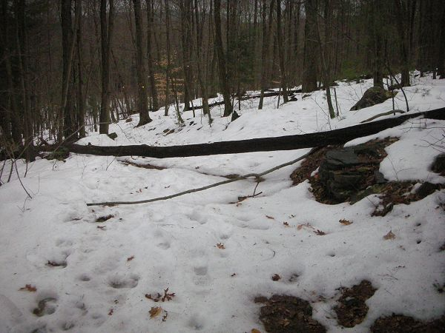

Abbreviations:
Usage type: foot traffic only (H), multi-use (M)

waterbars (wb) small blowdowns (sbd)
culverts(cv) large blowdowns (lbd)
rolling dips (rd) rock work (rkw)
bridges (br) bridge building (bbd),
bog bridges (bb) culvert replacement (cr)
rock stairs (rs) trail relocation (tr),
cribbing (cb) building new trail drainage (ntd)
retaining walls (rw) brushing needed (bn)
ditches (dt) excessive erosion (ee)
leaning tree (lt)

