TRAIL ASSESSMENT FORM

Doc. # | 1018 | Trail Name |  |  | Accord Path West | Trail Type: |  | Wide - M | Condition |  | Poor
Route: |  |  | Hillside Street FBH 1161- 1151 – FBH1137 - FBH1136 - FBH1125 – FBH1105 – FBH 1097 – FBH1096- 1086 – 1081 – 1062 – FBH1040 –FBH1013 – FBH1004 - Skyline South FBH1003 – FBH1005 – FBH1110 - Blue Hills Ski Area
Recent Weather: |  |  | 1/25/08 - Cold and Sunny in the 20’s – Snow cover on trail was 0-2 inches.  5/15/08 – Cloudy in the 60s. Light rain in last 24 hours
TRAIL LANDMARKS |  |  | - Trailhead leaves from the north side of Hillside Street at path width, directly across from the northeast corner of the Houghton Pond parking area. Trailhead is marked with three large rocks.  - For the purpose of this assessment, both the DCR (8/07) and the old FBH maps were used in the survey. Some portions of this trail do not appear on the DCR map. There is also one section of this trail shown on the FBH map that does not currently exist any more (overgrown and not navigable). It is however shown correctly on the DCR map. For these reasons, I will note both the DCR and FBH intersection markers for clarification and comment as required.  - Treadway begins ascending and levels out at .06 miles.  - Sbd crosses the treadway at .06 miles. Remove,  - Unnamed path (Houghton Hill Trail FBH) crosses at intersection marker 1151 at .09 miles.  - Treadway passes a large boulder on the left and a rock wall crosses at .13 miles.  - Old lbd extends into the treadway at .15 miles. Needs to be cutback more.  - Houghtons Path crosses at .22 miles. (No FBH 1137 noted)  - Unnamed path leaves on the right at .23 miles.  - Coon Hollow Path crosses at .32 miles. (No FBH 1136 noted)  - Unnamed path crosses at path width at .34 miles.  - Treadway crosses a stream at .35 miles with overhead bn.  - Bd crosses the treadway at .36 miles. Can be stepped over.  - Accord Path leaves the current (west) wide path on the right at .37 miles. This is a narrow lightly traveled path heading north. (No FBH 1125 noted) Need intersection marker here. (1)  - Bd crosses and a limb extends over the treadway at .37 miles. Bootleg trail around area. Should be removed.  - Lbd with limbs extending into the treadway at .42 miles. Limbs need to be cutback. (2)  - At this point a bootleg trail goes around to the right and it is at this point where I feel the original section of Accord Path east left through a bog to the Coon Hollow Path. The footpath today is barely discernable, runs in a streambed and not passable without machete. It does cross a damaged clay 12” cv within 50 yards.  - Accord Path winds its way northwest around the lbd noted above to the left of the treadway at .43 miles.  - Bn at .44 miles while treadway ascends.  - Minor erosion at .45 miles as treadway enters a low point.  - Bd extends into the treadway at .47 miles. Currently cutback however needs more to open path width.  - Treadway begins ascending with bn at .48 miles. Pine boughs.  - Downed limb in treadway at .49 miles. 8”. Bootleg trail around limb. Should be removed.  - Sbd at .52 miles. Can be stepped over.  - Overhead bn at .54 miles. Bd over treadway. 2” Bow saw with pine boughs.  - Bn at .55 miles. Pine boughs.  - Nice rock walls confine treadway narrowly at .56 miles and open up to road width while descending through .57 miles.  - Bd extending into the treadway at .15 miles. Needs to be cutback.  - Downed limb in the treadway at .14 miles. Remove.  - Accord Path enters the Five Corners Path at .63 miles and follows it north sharing the same treadway for 50 feet. (No FBH 1105 noted)  - Accord Path leaves the Five Corners Path on the left (west) at .64 miles. This section of Accord Path is not shown on the DCR map.  - Bn at .65 miles. Pine Boughs.  - Bn at .68 miles. Pine Boughs.  - Accord Path descends to and enters the northwest corner of a parking area on the north side of Hillside Street at .73 miles. (No FBH 1097 noted). Parking area is 1/8 of a mile west Blue Hills River Road.  - At this point, Accord Path continues west while sharing the same treadway with an unnamed path paralleling Hillside Street to the Wildcat Notch Trail trailhead. This trailhead is 275 feet from the parking area and is identified with a granite marker. (No FBH 1096 noted)  - Accord Path turns right (north) onto the Wildcat Notch Trail at .78 miles and shares the treadway to intersection marker 1086.  - Lbd across trail .80 miles. 20” dia.  - Widow maker .81 miles from trailhead, 20” dia. Remove before season. (3)  - Unnamed trail enters on left. Connector to fire road and unnamed side path.  - Trail opens to road width with brushing required at .82 miles.  - Accord Path leaves the Wildcat Notch Trail on the left (west) at intersection marker 1086 at .84 miles.  - Trail narrows to path width with Bn .87 miles from the trailhead.  - Halfway Path leaves on the right (north) at intersection marker 1081 at .93 miles from the trailhead.  - Trail descends into an area of minor erosion at 1.02 miles.  - Brookwood Trail crosses at intersection marker 1062 at 1.03 miles.  - Dt on left down to Hillside Ave. at 1.15 miles requires cleaning.  - Bn at 1.16 miles.  - Entering an area on moderate to severe erosion at 1.2 miles.  - Dt on left down to Hillside Ave. sewer at 1.2 miles requires cleaning. LBD in dt. 12” by 12’ needs to be removed.  - Roofed/Stone DCR structure to right of trail at 1.27 miles.  - Moderate to severe erosion continues as this trail ascends through 1.32 miles. It appears to me that this trail is intentionally used to channel runoff from the hill on the right of the trail. There is Rwk on the side of the trail in some areas to keep the runoff on the trail and divert it into Dt and sewers located on Hillside Ave. See Photo. (4)  - Dt on right side of trail paralleling trail for a short distance at 1.32 miles. Bd in Dt needs to be removed. Extending this Dt back to 1.2 miles would minimize treadway erosion through this area however this would be a major undertaking. See Photo. (5)  - Sbd (6” dia.) at 1.36 miles. Remove.  - Dt on left at 1.38 miles with Bd across it. Requires cleaning.  - Sbd at 1.42 miles extending into trail. Needs to be cut back.  - Sbd at 1.43 miles needs to be removed.  - Trail descends into an area of moderate to severe erosion at 1.43 miles. Again it appears to me that this trail is intentionally used to channel runoff from the hill on the right of the trail. Rkw on left. (6)  - Bn at 1.44 miles.  - Lbds cross trail at 1.49and 1.50 miles. Needs removal and Bn. (7) See Photos. 3 & 4  - Broken limbs block trail at 1.51 miles needs removal. (8) See Photo 5.  - Sbd at 1.55 miles needs removal.  - Rwk Wb at 1.55 miles. R to L. Dt on L. Needs cleaning major debris.  - Dt crosses trail at 1.59 miles. Cleaning and Bn.  - Nice rock steps ascending trail al at 1.64 miles.  - Rwk Wb at 1.64 miles. R to L. Dt on L. Needs cleaning.  - Moderate to severe erosion beginning at 1.64 miles. Bn 1.64 through 1.7 miles.  - Dt on left at 1.76 needs cleaning.  - Dt crosses trail at 1.78 miles. Cleaning and debris removal.  - Skyline South Trail crosses at 1.78 miles.  - Trail opens to road width at 1.78 miles.  - Lbd crosses at 1.88 miles. (8” Dia.) Needs removal.  - Unnamed path leaves on left to Rt. 138 at 1.99miles.  - Sbd at 2.01 miles. Removal and Bn.  - Sbd overhanging trail at 2.02 miles (4’ dia.) Bn.  - Fallen tree limb blocking trail at 2.1 miles. Needs removal and bn.  - Accord Path ends with its intersection with the chair lift at the Blue Hills Ski area at 2.12 miles.
MINOR  PROBLEM  AREAS |  |  | - Accord Path leaves the current (west) wide path on the right at .37 miles. This is a narrow lightly traveled path heading north. (No FBH 1125 noted) Need intersection marker here. (1)  - Lbd with limbs extending into the treadway at .42 miles. Limbs need to be cutback. (2)  - Widow maker .81 miles from trailhead, 20” dia. Remove before season. (3)  - Lbds cross trail at 1.49and 1.50 miles. Needs removal and Bn. (7) See Photos. 3 & 4  - Broken limbs block trail at 1.51 miles needs removal. (8) See Photo 5.
MAJOR  PROBLEM AREAS |  |  | - Moderate to severe erosion continues as this trail ascends through 1.32 miles. It appears to me that this trail is intentionally used to channel runoff from the hill on the right of the trail. There is Rwk on the side of the trail in some areas to keep the runoff on the trail and divert it into Dt and sewers located on Hillside Ave. See Photo. (4)  - Dt on right side of trail paralleling trail for a short distance at 1.32 miles. Bd in Dt needs to be removed. Extending this Dt back to 1.2 miles would minimize treadway erosion through this area however this would be a major undertaking. See Photo. (5)  - Trail descends into an area of moderate to severe erosion at 1.43 miles. Again it appears to me that this trail is intentionally used to channel runoff from the hill on the right of the trail. Rkw on left. (6)
DISTANCES TO MAJOR INTERSECTIONS |  |  | - Hillside Street Trailhead to - Houghton Hill Trail (FBH) crosses at intersection marker 1151 - .09 miles  - Hillside Street Trailhead to Houghtons Path crosses - .22 miles.  - Hillside Street Trailhead to Coon Hollow Path crosses - .32 miles.  - Hillside Street Trailhead to the Five Corners Path - .63 miles.  - Hillside Street Trailhead to the northwest corner of a parking area on the north side of Hillside Street - .73 miles.  - Hillside Street Trailhead to Accord Path turns right (north) onto the Wildcat Notch Trail - .78 miles  - Hillside Street Trailhead to Accord Path leaves the Wildcat Notch Trail on the left (east) at intersection marker 1086 - .84 miles.  - Hillside Street Trailhead to Halfway Path leaves on the right at intersection marker 1081 - .93 miles.  - Hillside Street Trailhead to Brookwood Trail crosses at intersection marker 1062 - 1.03 miles.  - Hillside Street Trailhead to Skyline South Trail crosses - 1.78 miles.  - Hillside Street Trailhead to Accord Path ends with its intersection with the Blue Hills Ski area - 2.12 miles.
Report prepared by: |  |  |  | Ken Jones |  |  | Assessment date: |  |  | 1/25/08 & 5/15/08

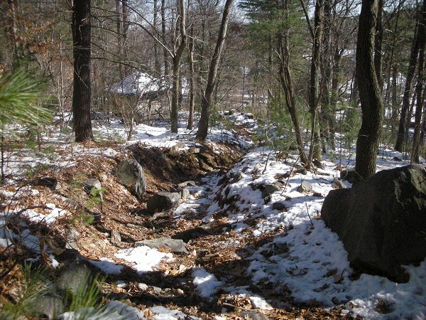

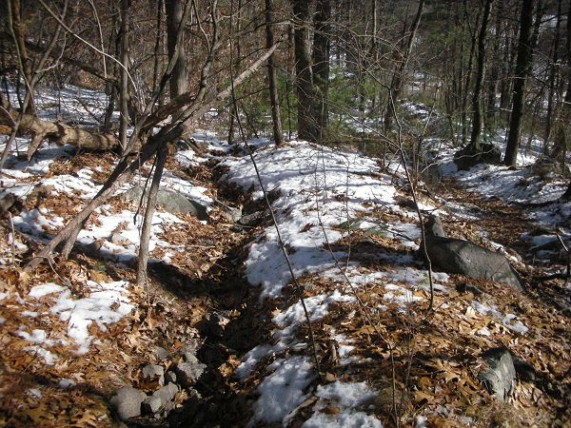

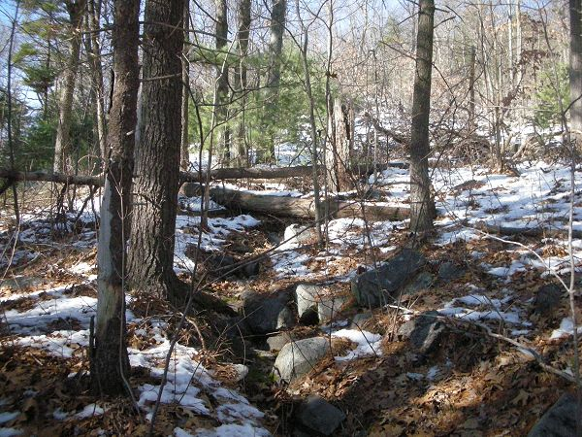

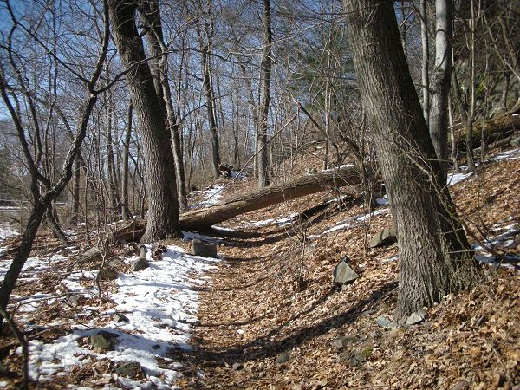

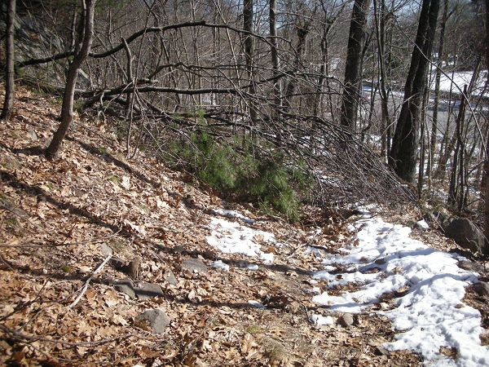

Abbreviations:

Usage type: foot traffic only (H), multi-use (M)

waterbars (wb) small blowdowns (sbd)
culverts(cv) large blowdowns (lbd)
rolling dips (rd) rock work (rkw)
bridges (br) bridge building (bbd),
bog bridges (bb) culvert replacement (cr)
rock stairs (rs) trail relocation (tr),
cribbing (cb) building new trail drainage (ntd)
retaining walls (rw) brushing needed (bn)
ditches (dt) excessive erosion (ee)

