TRAIL ASSESSMENT FORM

Doc. # | 1018 | Trail Name |  |  | Accord path West | Trail Type: |  | Wide - M | Condition |  | Poor
Route: |  |  | 1086 – 1081 – 1062 – Skyline South – Blue Hills Ski Area
Recent Weather: |  |  | Cold and Sunny in the 20’s – Snow cover on trail was 0-2 inches
TRAIL LANDMARKS |  |  | - Trailhead is located at intersection marker 1086. Accord Path leaves the Wildcat Notch Path on the Left, .12 miles form the North side of Hillside Street.  Wildcat Notch Path leaves at a granite marker from an unnamed side path that parallels Hillside Street on the north side, 275 feet west of a small parking area. Parking area is 1/8 of a mile west Blue Hills River Road.  - Trail narrows to path width with Bn 165 feet from the trailhead.  - Halfway Path leaves on the right at intersection marker 1081 at 435 feet from the trailhead.  - Trail descends into an area of minor erosion at .18 miles.  - Brookwood Trail crosses at intersection marker 1062 at .19 miles.  - Dt on left down to Hillside Ave. at .31 miles requires cleaning.  - Bn at .32 miles.  - Entering an area on moderate to severe erosion at .36 miles.  - Dt on left down to Hillside Ave. sewer at .36 miles requires cleaning. LBD in dt. 12” by 12’ needs to be removed.  - Roofed/Stone DCR structure to right of trail at .43 miles.  - Moderate to severe erosion continues as this trail ascends through .48 miles. It appears to me that this trail is intentionally used to channel runoff from the hill on the right of the trail. There is Rwk on the side of the trail in some areas to keep the runoff on the trail and divert it into Dt and sewers located on Hillside Ave. See Photo. (1)  - Dt on right side of trail paralleling trail for a short distance at .48 miles. Bd in Dt needs to be removed. Extending this Dt to .36 miles would minimize treadway erosion through this area however this would be a major undertaking. See Photo. (2)  - Sbd (6” dia.) at .52 miles. Remove.  - Dt on left at .54 miles with Bd across it. Requires cleaning.  - Sbd at .58 miles extending into trail. Needs to be cut back.  - Sbd at .59 miles needs to be removed.  - Trail descends into an area of moderate to severe erosion at .59 miles. Again it appears to me that this trail is intentionally used to channel runoff from the hill on the right of the trail. Rkw on left. (3)  - Bn at .6 miles.  - Lbds cross trail at .65 and .66 miles. Needs removal and Bn. (4) See Photos. 3 & 4  - Broken limbs block trail at .67 miles needs removal. (5) See Photo 5.  - Sbd at .71 miles needs removal.  - Rwk Wb at .71 miles. R to L. Dt on L. Needs cleaning major debris.  - Dt crosses trail at .75 miles. Cleaning and Bn.  - Nice rock steps ascending trail al at .8 miles.  - Rwk Wb at .8 miles. R to L. Dt on L. Needs cleaning.  - Moderate to severe erosion beginning at .8 miles. Bn .8 through .86 miles.  - Dt on left at .92 needs cleaning.  - Dt crosses trail at .94 miles. Cleaning and debris removal.  - Skyline South Trail crosses at .94 miles.  - Trail opens to road width at .94 miles.  - Lbd crosses at 1.04 miles. (8” Dia.) Needs removal.  - Unnamed path leaves on left to Rt. 138 at 1.15 miles.  - Sbd at 1.17 miles. Removal and Bn.  - Sbd overhanging trail at 1.18 miles (4’ dia.) Bn.  - Fallen tree limb blocking trail at 1.26 miles. Needs removal and bn.  - Accord Path ends with its intersection with the chair lift at the Blue Hills Ski area at 1.28 miles.
MINOR  PROBLEM  AREAS |  |  | - Trail is in serious need of maintenance with significant areas requiring tree and debris removal with many areas of brushing needed.  (4) Lbds cross trail at .65 and .66 miles. Needs removal and Bn. See Photos 3 & 4.  (5) Broken limbs block trail at .67 miles needs removal. See Photo 5.
MAJOR  PROBLEM AREAS |  |  | - Moderate to severe erosion continues as this trail ascends through .48 miles. It appears to me that this trail is intentionally used to channel runoff from the hill on the right of the trail. There is Rwk on the side of the trail in some areas to keep the runoff on the trail and divert it into Dt and sewers located on Hillside Ave. See Photo 1.  - Dt on right side of trail paralleling trail for a short distance at .48 miles. Bd in Dt needs to be removed. Extending this Dt to .36 miles would minimize treadway erosion through this area however this would be a major undertaking. See Photo 2.  - Trail descends into an area of moderate to severe erosion at .59 miles. Again it appears to me that this trail is intentionally used to channel runoff from the hill on the right of the trail. Rkw on left.
DISTANCES TO MAJOR INTERSECTIONS |  |  | - Trailhead marker 1086 to Half way Path Intersection marker 1081 - 435 feet.  - Trailhead marker 1086 to Brookwood Trail intersection marker 1062 - .19 miles.  - Trailhead marker 1086 to Skyline South Trail - .94 miles  - Trailhead marker 1086 to Blue Hills Ski area - 1.28 miles.
Report prepared by: |  |  |  | Ken Jones |  |  | Assessment date: |  |  | 1/25/2008

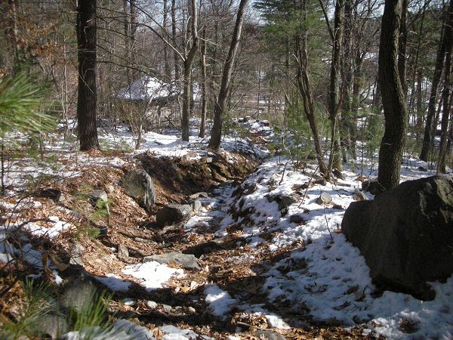

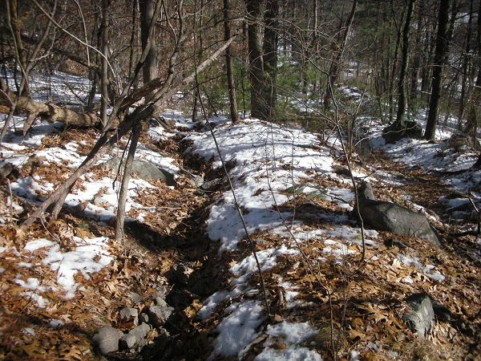

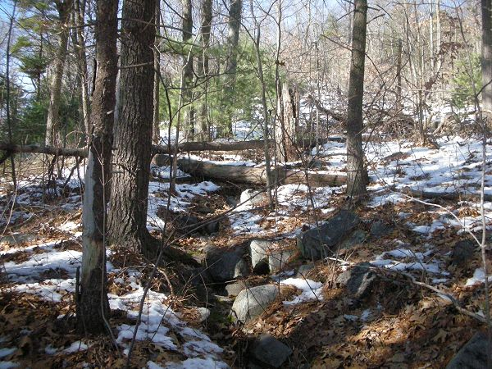

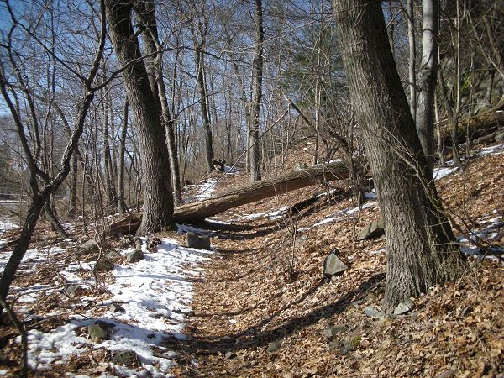

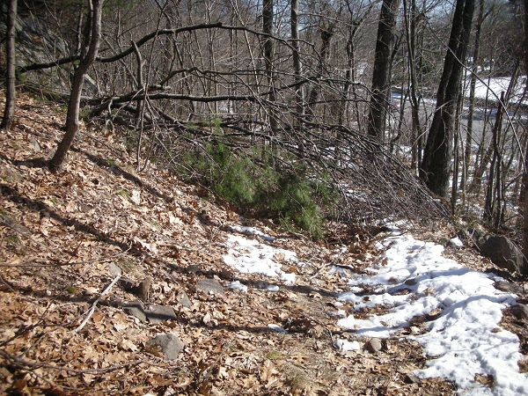

Abbreviations:

Usage type: foot traffic only (H), multi-use (M)

waterbars (wb) small blowdowns (sbd)
culverts(cv) large blowdowns (lbd)
rolling dips (rd) rock work (rkw)
bridges (br) bridge building (bbd),
bog bridges (bb) culvert replacement (cr)
rock stairs (rs) trail relocation (tr),
cribbing (cb) building new trail drainage (ntd)
retaining walls (rw) brushing needed (bn)
ditches (dt) excessive erosion (ee)

