TRAIL ASSESSMENT FORM

Doc. # | 1019 | Trail Name |  |  | Brookwood Trail North | Trail Type: |  | Narrow - M | Condition |  | Fair
Route: |  |  | Hillside Ave. – 1062 – Wildcat Notch path
Recent Weather: |  |  | Cold and Sunny in the 20’s – Snow cover on trail was 0-2 inches
TRAIL LANDMARKS |  |  | - Trailhead is located on the north side of Hillside Street approximately 3/8 of a mile west of the Hillside Street, Blue Hills River Road intersection.  - Trailhead is fairly hidden from the street however opens to a footpath once into the woods. Trailhead should be marked (1). Located across the street from the Brookwood Farm.  - Bn from trailhead to 300 feet.  - SBD crosses trail at 300 feet. Remove.  - Accord Path crosses at 307 feet.  - Bn at .1 miles.  - Minor erosion noted during ascent at .12 miles. Could Dt above trail to improve.  - Bn at .14 miles.  - Trail detours around an old Lbd at .16 miles and then rejoins the path.  - Bn at .19 miles.  - Rkw walls on L and R at .2 miles.  - Widow maker over trail at .22 miles. Old however should be removed. (2) See Photo.  - Bn at .25 -.27 miles.  - Bn at .39 miles.  - Bn at .43 miles.  - Sbd extending into trail at .43 miles. Needs to be cutback.  - Brookwood trail ends with its intersection with the Wildcat Notch path just south of the 1083-intersection marker at .41 miles.
MINOR  PROBLEM  AREAS |  |  | (1) Trailhead should be marked. Trailhead is fairly hidden from the street however opens to a footpath once into the woods.  - Trail needs significant brushing and removal of blowdowns as notes in the survey.
MAJOR  PROBLEM AREAS |  |  | (2) Widow maker over trail at .22 miles. Old however should be removed. See Photo.
DISTANCES TO MAJOR INTERSECTIONS |  |  | - Hillside Street Trailhead to 1062 – 307 feet.  - Hillside Street Trailhead to Wildcat Notch - .41 miles
Report prepared by: |  |  |  | Ken Jones |  |  | Assessment date: |  |  | 1/25/2008

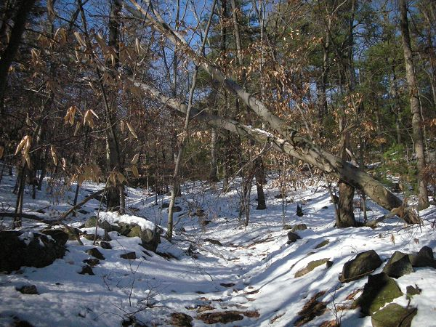

Abbreviations:

Usage type: foot traffic only (H), multi-use (M)

waterbars (wb) small blowdowns (sbd)
culverts(cv) large blowdowns (lbd)
rolling dips (rd) rock work (rkw)
bridges (br) bridge building (bbd),
bog bridges (bb) culvert replacement (cr)
rock stairs (rs) trail relocation (tr),
cribbing (cb) building new trail drainage (ntd)
retaining walls (rw) brushing needed (bn)
ditches (dt) excessive erosion (ee)
leaning tree (lt)

