TRAIL ASSESSMENT FORM

Doc. # | 1022 | Trail Name |  |  | Skyline Trail West | Trail Type: |  | Wide - M | Condition |  | Good
Route: |  |  | Intersection marker 1066 – Route 138 – 6800 – 6700 – Green St. - Route 95
Recent Weather: |  |  | Sunny in the 30’s – Melting Snow. Snow cover on trail was 0-1 inch
TRAIL LANDMARKS |  |  | - For survey purposes, the trailhead is located at intersection marker 1066 at the intersection of the South Skyline trail and Elliot Circle. There is a blue blaze opposite the South Skyline Trail granite marker located on a tree labeled Skyline to West and a direction arrow. The Skyline Trail West uses the same treadway as Elliot circle for .2 miles.  - Tar road to observatory leaves on right at 168 feet.  - Dt on left in dip at .14 miles. Clean.  - Tar road to observatory leaves on right at .16 miles.  - Skyline Trail West to Little Blue Hill leaves Elliot Circle on the left at .2 miles at Granite marker labeled Skyline Trail.  - Wonderful rock overlook at .22 miles.  - Trail enters and area of minor erosion at .30 miles.  - Rkw dt at .4 miles into another dt across trail. R to L. Needs cleaning.  - Bn at .42 miles.  - Accord Path crosses at .45 miles.  - Nice Rkw steps at .48 miles as treadway leaves a run off section and drainage area filled with large boulders to the left of the treadway.  - Rwk wb at .48 miles. R to L. Dt on right. Needs cleaning.  - Rwk wb at .5 miles. R to L. Dt on right. Needs cleaning. Dt leads into a very large cv running under route 138.  - Sbd at .51 miles. Bow saw work.  - Trail crosses route 138 at .52 miles at a granite marker labeled Skyline Trail. Sign on tree at this location labeled Skyline to great Blue Hill.  - Skyline reenters the woods after crossing route 138 at a blue blaze on the guardrail 20 feet to the north with a granite marker on the other side of the guardrail.  - Treadway becomes a footpath at this point.  - Unnamed path leaves on the right at .6 miles.  - Bn at .65 miles.  - Unnamed path crosses at .71 miles.  - Sbd crosses the trail at .75 miles. Bn and bow saw work.  - Mountain path leaves on the right at .77 miles with green dot blazes.  - Green dot blazes and the Skyline follow the same treadway for .06 miles.  - Bn and debris removal required at .80 miles.  - K Path crosses at intersection marker 6800 at .83 miles. Green dot blazes follow K path on left.  - Treadway enters an area of sbds, broken limbs and bn at .88 miles. Much debris blocking trail. (1) (Photo SLW1)  - LBD with limbs hanging into the treadway at .92 miles. Chainsaw removal required. (2) (Photo SLW2)  - Bn at .96 miles.  - Bn at .99 miles.  - Cosmos path Crosses at intersection marker 6700 at 1.05 miles. Cosmos Path blazed with greed dots.  - Bn at .1.07 miles.  - Widow maker (8’ x8”) hanging over treadway with lbd (8’ dia.) blocking treadway at 1.1 miles. Chainsaw removal required. (3) (Photo SLW3)  - Sbd extending into treadway at 1.17 miles. Bow saw work.  - Bn at 1.25 miles. Downed limb with branches crossing treadway. Bow saw work.  - Bn at 1.27 miles. Downed limb with branches crossing treadway. Bow saw work.  - Bn at 1.3 miles. Downed limb with branches crossing treadway. Bow saw work.  - Green Street crosses at 1.33 miles.  - Bn at 1.34 miles. Downed limb with branches crossing treadway. Bow saw work.  - Bn at 1.43 miles. Downed limb with branches crossing treadway. Bow saw work.  - Spur path leaves on left to Royal Street at 1.44 miles  - Bn at 1.45.  - Large rock wall to right of treadway at 1.45.  - Bn at 1.47.  - Trail crosses a broken down large rock wall at 1.49 miles.  - Sbd blocking trail at 1.5 miles.  - Bn at 1.51 miles. Downed limbs blocking trail. Bow saw work.  - Bn at 1.53 miles. Downed limbs and briars blocking trail. Bow saw, lopper work.  - Skyline Trail West ends at the on ramp to I-95 south at 1.54 miles from the trailhead.
MINOR  PROBLEM  AREAS |  |  | - Overall the treadway is in good condition however there is allot of brushing and debris removal work required west of route 138 that gets progressively worse the farther west you go as noted in the survey.  - Treadway enters an area of sbds, broken limbs and bn at .88 miles. Much debris blocking trail. (Photo SLW1)  - Widow maker (8’ x8”) hanging over treadway with lbd (8’ dia.) blocking treadway at 1.1 miles. Chainsaw removal required. (Photo SLW2)
MAJOR  PROBLEM AREAS |  |  | - None noted
DISTANCES TO MAJOR INTERSECTIONS |  |  | - Trailhead at 1066 to Skyline Trail West leaves Elliot Circle. - 2 miles.  - Trailhead at 1066 to Accord Path. - 45 miles  - Trailhead at 1066 to Route 138.- .52 miles  - Trailhead at 1066 to K Path at intersection marker 6800. - .83 miles  - Trailhead at 1066 to Cosmos path Crosses at intersection marker 6700. - 1.05 miles  - Trailhead at 1066 to Green Street. - 1.33 miles  - Trailhead at 1066 to the end of the Skyline Trail West at I95 south - 1.54 miles
Report prepared by: |  |  |  | Ken Jones |  |  | Assessment date: |  |  | 1/28/2008

SLW1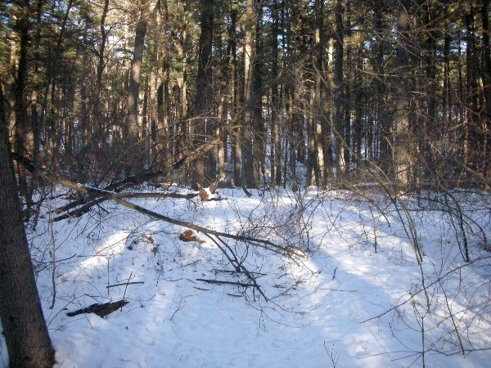
SLW2
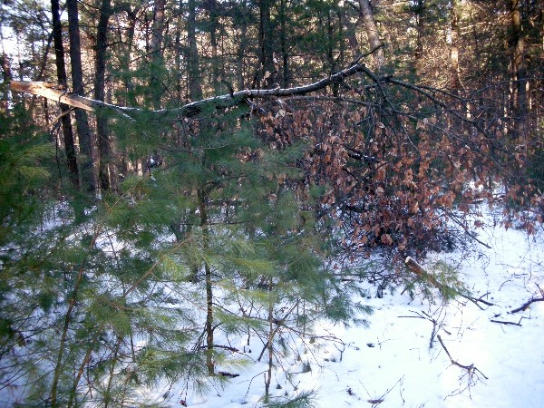
SLW3
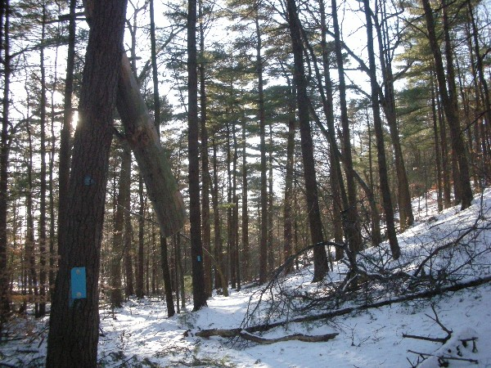

Abbreviations:

Usage type: foot traffic only (H), multi-use (M)

waterbars (wb) small blowdowns (sbd)
culverts(cv) large blowdowns (lbd)
rolling dips (rd) rock work (rkw)
bridges (br) bridge building (bbd),
bog bridges (bb) culvert replacement (cr)
rock stairs (rs) trail relocation (tr),
cribbing (cb) building new trail drainage (ntd)
retaining walls (rw) brushing needed (bn)
ditches (dt) excessive erosion (ee)
leaning tree (lt)

