TRAIL ASSESSMENT FORM

Doc. # | 1023 | Trail Name |  |  | Puddle Path South | Trail Type: |  | Wide - M | Condition |  | Good
Route: |  |  | Wolcott Path 1085 –1105 – Wildcat Notch Path 1103
Recent Weather: |  |  | Rainy today – No snow on trail
TRAIL LANDMARKS |  |  | - Puddle Path Trailhead leaves Wolcott Path on the right at intersection marker 1085, .41 miles from the Trailside Museum North parking area. Trail is blazed with green dots.  - Cv crosses under the treadway L to R immediately leaving Wolcott Path. Rkw both sides with steel corrugated pipe ( 14”). Two large boulders in outlet on right need to be removed from dt.  - Unnamed path leaves on right at 100 feet.  - Wwb at 154 feet. R to L. Dt on R and L. Clean wb and dts.  - Cv crosses under the treadway at 204 feet. Rkw both sides with PVC corrugated pipe ( 12”). Rkw well on right needs cleaning as does dt feeding well.  - Rd at 250 feet. Dt on right leading into well noted above. Not effective. Rd and dt needs to be deeper as there is minor erosion in trail following rd. (1)  - Rd at 355 feet. R to L. Rd and dt needs to be deeper and cleaned.  - Bn at 429 feet.  - Rd at 475 feet. L to R. Rd and dt needs to be deeper on right and cleaned.  - Rd at .1 miles. R to L. Rd and dt needs to be deeper on left and cleaned.  - Wwb at .12 miles. R to L removing water from trail. Clean and dt better on left.  - Bn at .14 miles.  - Bn at .16 miles.  - Tree limb overhanging trail at .18 miles needs to be removed or cut back. Bow saw work however ladder required. (2) (Photo PP1 attached.)  - Unnamed Path leaves on right at intersection marker 1105 at .19 miles.  - Rd at .2 miles. R to L. Rd and dt needs cleaning.  - Bn at .29 miles.  - Puddle Path ends with its intersection with Wildcat Notch Path at intersection marker 1103 at .37 miles.
MINOR  PROBLEM  AREAS |  |  | (1) Rd at 250 feet not effective. Rd and dt needs to be deeper as there is minor erosion in trail following rd.  (2) Tree limb overhanging trail at .18 miles needs to be removed or cut back. Bow saw work however ladder required. (2) (Photo PP1 attached.)
MAJOR  PROBLEM AREAS |  |  | - None noted
DISTANCES TO MAJOR INTERSECTIONS |  |  | - Trailhead at 1085 to intersection marker 1105 - .19 miles.  - Trailhead at 1085 to Puddle Path ends at its intersection with Wildcat Notch Path at intersection marker 1103 - .37 miles.
Report prepared by: |  |  |  | Ken Jones |  |  | Assessment date: |  |  | 2/5/2008

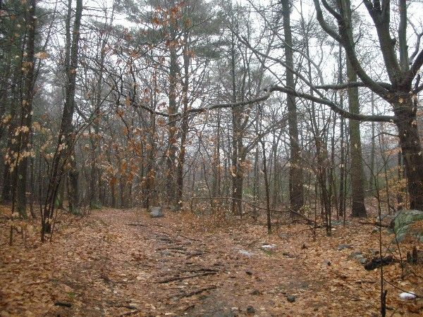

Abbreviations:

Usage type: foot traffic only (H), multi-use (M)

waterbars (wb) small blowdowns (sbd)
culverts(cv) large blowdowns (lbd)
rolling dips (rd) rock work (rkw)
bridges (br) bridge building (bbd),
bog bridges (bb) culvert replacement (cr)
rock stairs (rs) trail relocation (tr),
cribbing (cb) building new trail drainage (ntd)
retaining walls (rw) brushing needed (bn)
ditches (dt) excessive erosion (ee)
leaning tree (lt)

