TRAIL ASSESSMENT FORM

Doc. # | 3002 | Trail Name |  |  | Romari Trail | Trail Type: |  | Narrow M | Condition |  | Good
Route: |  |  | Starts at east end of Wood Path, heading southwest along the park boundary, ends at another un trail. Approx. ¼ mi. long
Recent Weather: |  |  | Has snowed and mostly melted since. Trail is muddy in some spots, dry others, snow/ice covered in spots also.
TRAIL LANDMARKS |  |  | *Access from Wood Road gate at Wood path. No legal parking but a large lot across Wood Road.  *Trail starts at sbout 70 yards in on Wood Path(heading west)on the left.  *The map shows this trail as perfectly straight, running along the park boundary for ¼ mi. It does meander some, with slight rolling hills.  *Mostly hard pack terrain, but some technical with loose rocks on the hilly sections.  *Biggest landmarks are the industrial businesses on the SE side of the trail that can be seen and heard from most of the trail.  * 8ft. bb with stagnant water 141 yds from start(1)  *cv/dt at same point, leading under ind. park lot.  *rw/cv behind ind. pk.pkg lot 257 yds. The rw/cv on the SE side of the trail is approx 10 yards back from the trail, draining perpendicular to trail(2)  *ee across trail at same point(2)  *wood stakes, test pipe, and ‘wetland delination’ flags at same point  *trail ends at another un trail behind a ind pk Quonset hut.  * Left (E)onto this trail ends abrubtly at an ind pk fence  *Right onto this un trail leads to intersect(s) with Wampatuck Path
MINOR  PROBLEM  AREAS |  |  | A cutback crew could easily maintain this trail in less than an hour.
MAJOR  PROBLEM AREAS |  |  | 1) bb/cv/dt drainage issues. BB is in bad shape, needs replacing. An armored stream crossing with ‘stepping stones’ would probably suffice. Whether the cv functions well is unknown, may handle spring runoff, but is not helping drain now. Water that crosses the trail is not moving at all. Backup of leaves at this point are part of the problem, however, this part of the trail runs next to a bog.  The cv is out of park boundary  (2) This rw/cv is a storm runoff that runs down the rock embankment and apparently washing silt down across trail. This has resulted in a muddy stretch approx. 20 yards long. This could be alleviated by building an armored ntd/rd.
DISTANCES TO MAJOR INTERSECTIONS
Report prepared by: |  |  |  | Steve Cobble |  |  | Assessment date: |  |  | 12/12/07

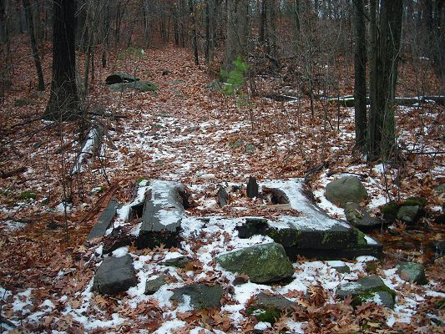

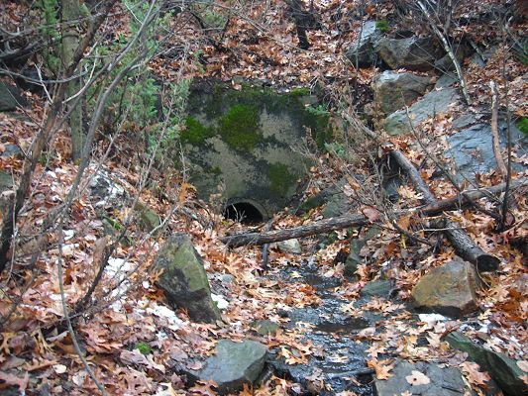

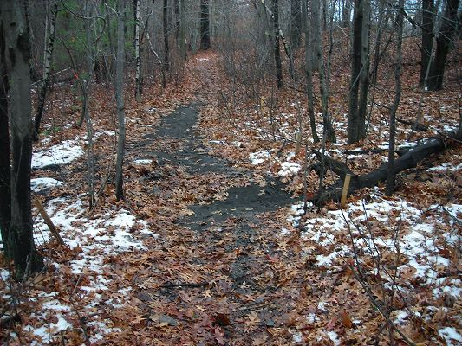

Abbreviations:

Usage type: foot traffic only (H), multi-use (M)

waterbars (wb) small blowdowns (sbd)
culverts(cv) large blowdowns (lbd)
rolling dips (rd) rock work (rkw)
bridges (br) bridge building (bbd),
bog bridges (bb) culvert replacement (cr)
rock stairs (rs) trail relocation (tr),
cribbing (cb) building new trail drainage (ntd)
retaining walls (rw) brushing needed (bn)
ditches (dt) excessive erosion (ee)
leaning tree (lt)

