TRAIL ASSESSMENT FORM

Doc. # | 3019A | Trail Name |  |  | Skyline Trail East Route 28 to Shea Rink | Trail Type: |  | Wide - M | Condition |  | Good
Route: |  |  | Route 28 – 3042 – 3103 – 3132 – 3144 – 4155- 4174 – 4184 – 4214 – 4220 – Shea Rink
Recent Weather: |  |  | Sunny, cool, dry.
TRAIL LANDMARKS |  |  | - Bd between pipeline and 3042.  - Bn on Chickatawbut Hill along Education Center continuing over Fenno Hill, Kitchamakin Hill and Nahanton Hill.  - Bd on Nahanton Hill just east of 3132.  - Bd on Nahanton Hill just as trail approaches Chickatawbut Road.  - Bn on Wampatuck Hill and to lesser extent on Rattlesnake Hill.  - Ee on Rattlesnake Hill section just past quarry going downslope to 4174 continuing past 4184. Need 3 – 4 grade reversals.  - Bn on area approaching and along St. Moritz Ponds.
MINOR  PROBLEM  AREAS |  |  | Water on the trail running down the northeast slope of Rattlesnake Hill needs to be addressed before the damage gets worse.
MAJOR
PROBLEM AREAS
DISTANCES TO MAJOR INTERSECTIONS
Report prepared by: |  |  |  | Caleb Blankenship |  |  | Assessment date: |  |  | 10/10/10

Abbreviations:

Usage type: foot traffic only (H), multi-use (M)

waterbars (wb) small blowdowns (sbd)
culverts(cv) large blowdowns (lbd)
rolling dips (rd) rock work (rkw)
bridges (br) bridge building (bbd),
bog bridges (bb) culvert replacement (cr)
rock stairs (rs) trail relocation (tr),
cribbing (cb) building new trail drainage (ntd)
retaining walls (rw) brushing needed (bn)
ditches (dt) excessive erosion (ee)
leaning tree (lt)

V5 NDR

TRAIL ASSESSMENT FORM

Doc. # | 3019 | Trail Name |  |  | Skyline Trail East Route 28 to Chickatawbut Road | Trail Type: |  | Wide - M | Condition |  | Good
Route: |  |  | Route 28 – 3042-3103 – 3132 – 3144 - Chickatawbut Road
Recent Weather: |  |  | Rain yesterday. .5 inches
TRAIL LANDMARKS |  |  | - This section of the Skyline Trail leaves from the east side of route 28 across from the parking turnout. Trailhead is approximately 5/8 of a mile north of route 93, exit 5. Turnoff parking available for approximately 3 vehicles. Trail is blazed with blue rectangles,  - Sbd 2/3 of the way into treadway at 190 feet. Needs to be moved (2 people) or cut back.  - Pipeline path crosses at 265 feet.  - Graffiti on a blue blaze on tree to the right of the treadway when reentering woods at 450 feet. Graffiti is bootleg 3014 intersection marker not shown on map.  - Water runoff from Pipeline Path and Hawk Hill running into the treadway covering the full width of the treadway with 2 inches of water. Flooding continues from the intersection at 450 feet through .16 miles. Possible extended bog bridge location. (1) (photos sle1 and sle2)  - Bn at .12 miles.  - Two downed limbs at .15 miles need to be hauled off the treadway.  - Bn at .19 miles.  - Flooding in treadway at .22 miles. Could be alleviated if several dt were dug leaving the treadway on the left.  - Bn at .26 miles.  - Bn at .29 miles.  - Bn at .31 miles.  - Braintree Pass Path crosses and the Bouncing Brook Path enters at intersection marker 3042 at .35 miles. Braintree Pass Path is blazed with red dots. Additional signage on tree notes Skyline Trail West to Great Blue Hill.  - Skyline and Braintree Pass Path utilize the same treadway here as trail opens to road width.  - Skyline leaves Braintree Pass Path on the left at .4 miles as treadway returns to footpath width and begins ascending Chickatawbut Hill. Signage on tree notes, Skyline Trail East to St. Moritz Pond.  - Downed limbs need to be removed at .41 miles.  - Outdated DCR Burn Area placard needs to be removed at .44 miles.  - Bn and downed limb removal at .49 miles.  - Bn at .52 miles.  - Treadway enters a large clearing with a nice large rock slab overlook at .68 miles.  - Unnamed path leaves on the left at .74 miles.  - Sbd at .76 miles. Needs to be hauled off treadway or cut back. Acting as an ineffective wb. (6-8”)  - Trail reaches Chickatawbut Hill height of land at the chain link fence surrounding the Education Center at .79 miles. Treadway from here continues to parallel the fence for .16 miles.  - Unnamed path leaves on the right at .84 miles to a nice overlook and beyond.  - Bn at .86 miles.  - Gate located in fence at .93 miles.  - Treadway turns right away from the fence at .95 miles while an unnamed path continues straight following the fence around the Education Center.  - Trail begins it’s descent from Chickatawbut at .98 miles over a set of nice rock steps with retaining walls.  - Bn at 1.02 miles.  - Rwb at 1.05 miles. R to L. Needs dt on left to be effective.  - Trail descends Fenno Hill at 1.07 miles over a set of rock steps with retaining walls. Bn on steps.  - Slide Notch Path crosses at 1.1 miles. Blazed with red dots.  - Treadway passes over additional sections of small rock steps at 1.12, 1.14 and 1.17 miles.  - Treadway descends into a trail intersection over an additional set of rock steps with retaining walls at 1.18 miles. Bn at this location.  - Skyline Trail enters the intersection at intersection marker 3103 at 1.22 miles. From this intersection, the Slide Notch Path, Yellow Dot trails, Skyline and Sassaman Notch Path leave with appropriate directional signage. Note: I believe the map shows this intersection marker 3103 further east than it actually is. (2)  - Skyline leaves the intersection and begins ascending Nahanton Hill over a set of rock steps with retaining walls. Bn on steps.  - Unnamed Paths leave on left at 1.26 and 1.27miles.  - Unnamed Path leaves on right at 1.3 miles.  - Unnamed Path leaves on left at 1.32 to a nice rock slab overlook.  - Major bn at 1.38 through 1.42 miles. Huge number small birch blowdowns. (3)  - Major similar bn as noted above at 1.44 and 1.47 miles.  - Unnamed path crosses at intersection marker 3132 at 1.5 miles. Path is road width however map only shows a small path entering on left.  - Trail ascends out of this intersection over a section of rock steps.  - Major similar bn as noted above at 1.53 through 1.57 miles.  - Major similar bn as noted above at 1.61 through 1.64 miles.  - Blazed tree down to right of trail at 1.69. Relocate blaze.  - Squamaug Path/Squamaug Notch cross at intersection marker 3144 at 1.74 miles. Squamaug Path enters on the left through an open gate at the fence surrounding the Blue Hill Reservoir. Treadway continues to parallel the fence.  - Bn at 1.79 miles.  - Sbd crosses trail at 1.8 miles. Bow saw work.  - Sbd crosses trail at 1.82 miles. Bow saw work.  - Bn at 1.9 and 1.91 miles. Sbd. Bow saw work  - Bn at 2.0 miles as treadway stops paralleling fence. Sbd. Bow saw work  - Uprooted tree crosses trail at 2.01 miles. Needs to be cut back (8”).  - Sbd extending into treadway at 2.03 miles. Needs to be cut back.  - Bd crosses treadway at 2.12 miles. Needs to be cut back (8”).  - This section of the Skyline East ends at it’s intersection with Chickatawbut Road at 2.18 miles. Granite marker at this location labeled Skyline Trail 6.7 miles. There is some minor erosion as the treadway descents to the road. Possible rwk steps to resolve. (4)
MINOR  PROBLEM  AREAS |  |  | - Water runoff from Pipeline Path and Hawk Hill running into the treadway covering the full width of the treadway with 2 inches of water. Trail is impassable. Flooding continues from the intersection at 450 feet through .16 miles. Possible extended bog bridge location. (1) (photos sle1 and sle2)  - Skyline Trail enters the intersection at intersection marker 3103 at 1.22 miles. Note: I believe the map shows this intersection marker 3103 further east than it actually is. (2)  - Significant bn at 1.38 through 1.42 miles. Huge number small birch blowdowns. (3) Similar significant bn at 1.44-1.47, 1.53-1.57, and 1.61-1.64 miles. Mucho Lopper work.  - Chickatawbut Road at 2.18 miles. There is some minor erosion as the treadway descents to the road. Possible rwk steps to resolve. (4)
MAJOR  PROBLEM AREAS |  |  | - None Noted
DISTANCES TO MAJOR INTERSECTIONS |  |  | - Route 28 to Pipeline - 265 feet  - Route 28 to Braintree Pass and Bouncing Brook Paths at intersection marker 3042. - .35 miles.  - Route 28 to Chickatawbut Hill and Education Center. - .79 miles.  - Route 28 to Slide Notch Path. - 1.1 miles  - Route 28 to intersection of Slide Notch, Yellow Dot, and Sassaman Notch Paths at intersection marker 3103. - 1.22 miles.  - Route 28 to unnamed path at intersection marker 3132. - 1.5 miles  - Route 28 to Squamaug Path/Squamaug Notch at intersection marker 3144. - 1.74 miles.  - Route 28 to Chickatawbut Road. - 2.18 miles
Report prepared by: |  |  |  | Ken Jones |  |  | Assessment date: |  |  | 2/19/2008

SLE1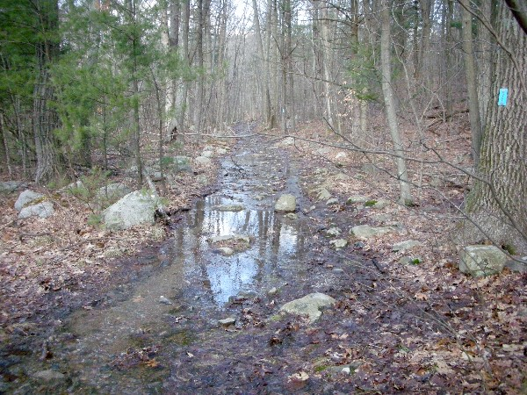

SLE2

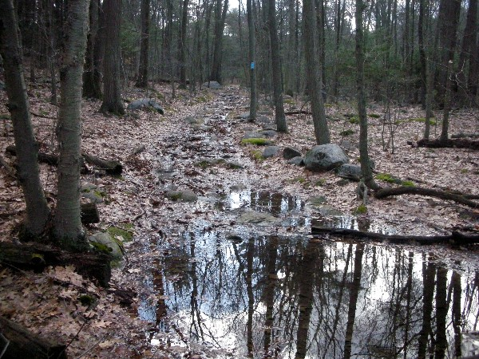

Abbreviations:

Usage type: foot traffic only (H), multi-use (M)

waterbars (wb) small blowdowns (sbd)
culverts(cv) large blowdowns (lbd)
rolling dips (rd) rock work (rkw)
bridges (br) bridge building (bbd),
bog bridges (bb) culvert replacement (cr)
rock stairs (rs) trail relocation (tr),
cribbing (cb) building new trail drainage (ntd)
retaining walls (rw) brushing needed (bn)
ditches (dt) excessive erosion (ee)
leaning tree (lt)

