TRAIL ASSESSMENT FORM

Doc. # | 6005 | Trail Name |  |  | Green Hill Path North | Trail Type: |  | Wide - M | Condition |  | Good
Route: |  |  | 6101 – 6102 –6103 – 6104 – 6105 – 6106 – Park Boundary
Recent Weather: |  |  | Moderate rain in last 24 hours – Sunny and 32 degrees
TRAIL LANDMARKS |  |  | - Trailhead leaves from intersection marker 6101 at road width immediately after a broken DCR gate and well point to the right of the treadway.  - Note: Access to this area can be from Burma Road or Royal Street. For the purpose of this assessment, the trail was accessed via Royal Street as follows;  - Trail is accessed via an unnamed footpath noted on the DCR map that leaves from the north side of Royal Street. The footpath is directly across the street from the Compushare Company parking area at 15 Royal Street.  - This unnamed footpath intersects the Skyline Trail at .14 miles.  - Turn left (west) at this intersection and follow the Skyline Trail to its end at the I-95 ramp at .22 miles.  - From this point, a footpath continues northwest and crosses a cement culvert at .23 miles.  - The footpath ends at an abandoned tar road noted on the DCR map at .26 miles. This road is barricaded at .37 miles however continues beyond the barricade paralleling a DPW yard on the left.  - Tar road narrows at .53 miles and continues.  - A dirt road leaves on the right to the trailhead at .59 miles at a broken DCR fire gate.  - The Orchard Trail leaves on the right at road width at 144 feet.  - The original trailhead for the Field Path leaves on the left at intersection marker 6102 at 240 feet.  - The 6102 intersection marker is broken and unreadable. There is an old bootleg marker on the tree as well labeled 6101 and 6210 with arrows. This trail when assessed from this trailhead is impassable very quickly due to debris and blowdowns and in my opinion was abandoned.(1)  - Bn at 300 feet. Downed limbs and vines.  - Lbd crosses treadway at 450 feet making road impassable. 14” diameter. (2) (see photo GHP19)  - Bn at .1 miles. Side and overhead.  - Bn at .13 miles. Pine boughs extending into the treadway.  - Treadway begins descending into Fowl Meadow at .16 miles at road width.  - Treadway continues descending through .23 miles at road width.  - Bn at .25 miles. Side.  - Sbd crosses the treadway at .28 miles. Can be pulled off.  - Unnamed path (Field Path) enters on the left at .29 miles. Trailhead is obscure and is at footpath width. Intersection marker 6103 could not be located in the field. (3)  - The Orchard Trail enters on the right at intersection marker 6104 at .37 miles at road width.  - The Swamp Trail enters on the left at intersection marker 6105 at .41 miles at road width.  - Spur trail to the Swamp trail enters on the left at .43 miles at road width.  - Unnamed path leaves on the right at intersection marker 6106 at .45 miles at road width. Lbd crosses this road making impassable.  - Bd extends into the treadway at .45 miles. 8” diameter. Can be driven around.  - The Green Hill Path ends at an unnamed road width path at .58 miles at the Park Boundary.  - This road width path is not shown on the DCR map. To the left (NW) it leads to the Fowl Meadow Path in 1/8 mile. To the right (SE) it leads into private property at .11 miles. There is a granite 8x8” unnamed marker to the right of the treadway at .10 miles.
MINOR  PROBLEM  AREAS |  |  | - The 6102 intersection marker is broken and unreadable. There is an old bootleg marker on the tree as well labeled 6101 and 6210 with arrows. The Field Path when assessed from this trailhead is impassable very quickly due to debris and blowdowns and in my opinion was abandoned.(1)  - Lbd crosses treadway at 450 feet making road impassable. 14” diameter. (2) (see photo GHP1)  - Unnamed path (Field Path) enters on the left at .29 miles. Trailhead is obscure and is at footpath width. Intersection marker 6103 could not be located in the field. (3)
MAJOR  PROBLEM AREAS |  |  | - None noted
DISTANCES TO MAJOR INTERSECTIONS |  |  | - Green Hill Path trailhead to the Orchard Trail - 144 feet  - Green Hill Path trailhead to the Field Path at intersection marker 6102 - 240 feet.  - Green Hill Path trailhead to the Field Path at Intersection marker 6103 - ?? miles.  - Green Hill Path trailhead to Orchard Trail at intersection marker 6104 - .37 miles  - Green Hill Path trailhead to Swamp Trail at intersection marker 6105 - .41 miles  - Green Hill Path trailhead to Unnamed path at intersection marker 6106 - .45 miles  - Green Hill Path trailhead to the Green Hill Path ends at the Park Boundary - .58 miles.
Report prepared by: |  |  |  | Ken Jones – 12/18/2008 |  |  | Assessment date: |  |  | 12/17/2008

GHP19
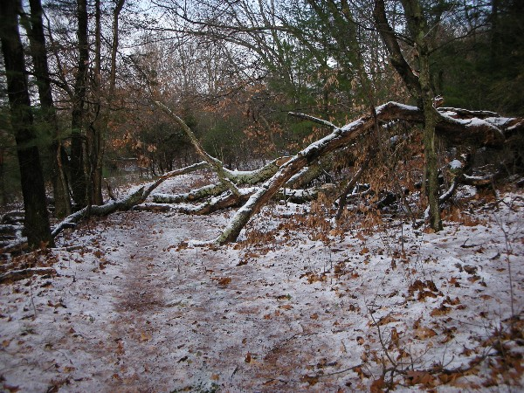

Abbreviations:

Usage type: foot traffic only (H), multi-use (M)

waterbars (wb) small blowdowns (sbd)
culverts(cv) large blowdowns (lbd)
rolling dips (rd) rock work (rkw)
bridges (br) bridge building (bbd),
bog bridges (bb) culvert replacement (cr)
rock stairs (rs) trail relocation (tr),
cribbing (cb) building new trail drainage (ntd)
retaining walls (rw) brushing needed (bn)
ditches (dt) excessive erosion (ee)
leaning tree (lt)

