TRAIL ASSESSMENT FORM

Doc. # | 4008 | Trail Name |  |  | Crag Trail South | Trail Type: |  | Wide - M | Condition |  | Good
Route: |  |  | 4153 – 4135 – 4131 – Chickatawbut Road
Recent Weather: |  |  | Rain within last 24 hours. Sunny in the 30’s
TRAIL LANDMARKS |  |  | - Trailhead leaves Crags Foot Path southwest at intersection marker 4153. This trail is noted as an unnamed path on DCR maps however is identified as Crags Trail on the old FBH map.  - Bn leaving intersection as treadway ascends. Downed limbs. Bow saw.  - Bn at 278 feet.  - Bd extending into the treadway on left at 466 feet. 14” needs to be cutback. Chainsaw.  - Bn at .1 miles Overhead and side.  - Treadway enters the pipeline area and the Green Dot Trail/Indian Camp Path at .12 miles and uses the same treadway for 150 feet to intersection marker 4135.  - Crag Trail leaves on the left crossing the pipeline (Southwest) while the Green Dot Trail/Indian Camp Path leave on the right at intersection marker 4135 at .15 miles.  - Additional signage would be helpful on the east side of the pipeline noting the Crag Trail. (1)  - Bn at .23 miles on left as treadway rejoins the pipeline for a short period.  - Treadway leaves the pipeline at .25 miles with a bd extending into the treadway. Cutback. 8” bow saw.  - Treadway continues to parallel the pipeline.  - Bd crosses the treadway at .28 miles with bn. Cut out of treadway. Bow saw.  - Bn at .29 miles.  - Unnamed path leaves on the left at .3 miles to the pipeline as Crags Trail turns east.  - Bn at .33 miles. Downed limbs. Bow saw and loppers.  - Two bd across treadway at .37 miles. 6’ and 12”. Need to be cutback. Bow saw.  - Treadway enters an intersection with an unnamed path leaving on the right at .4 miles with bn.  - Treadway enters an intersection at intersection marker 4131 at .41 miles. An unnamed path leaves on the right (west) to the pipeline, another on the left (east) to the Skyline Trail while the right fork (south) leads to Chickatawbut Road.  - Bd crosses the treadway at .42 miles. Two peopled require to pull off treadway.  - Unnamed path leaves on the right to the pipeline at .44 miles.  - Lbd crosses the treadway at .45 miles. Crosses fire road. Chainsaw. (2) (see photo ct1)  - Unnamed path leaves on the right to the pipeline at .47 miles.  - Large pile of road tar in treadway at .47 that should be removed. Reservoir reconstruction in this area.  - Crag Trail ends with its intersection with Chickatawbut Road at .5 miles.  - At this point on Chickatawbut Road there are no identifying markers for this trailhead other than a white reflective blaze on a telephone pole #18 directly across the street from the reservoir construction entrance. Trailhead is located .1 miles west of the skyline Trails intersection with Chickatawbut Road. Trailhead should be identified properly. (3)
MINOR  PROBLEM  AREAS |  |  | - Additional signage would be helpful on the east side of the pipeline noting the Crag Trails location as it opens to road width. (1)  - Lbd crosses the treadway at .45 miles. Crosses fire road. Chainsaw. (2) (see photo ct1)  - Signage required to identify trailhead on Chickatawbut Road. (3)
MAJOR  PROBLEM AREAS |  |  | - None noted
DISTANCES TO MAJOR INTERSECTIONS |  |  | - Intersection marker 4153 to Green Dot Trail/Indian Camp Path - .12 miles  - Intersection marker 4153 to intersection marker 4135 - .15 miles.  - Intersection marker 4153 to intersection marker 4131 - .41 miles.  - Intersection marker 4153 to Chickatawbut Road - .5 miles.
Report prepared by: |  |  |  | Ken Jones |  |  | Assessment date: |  |  | 3/13/2008

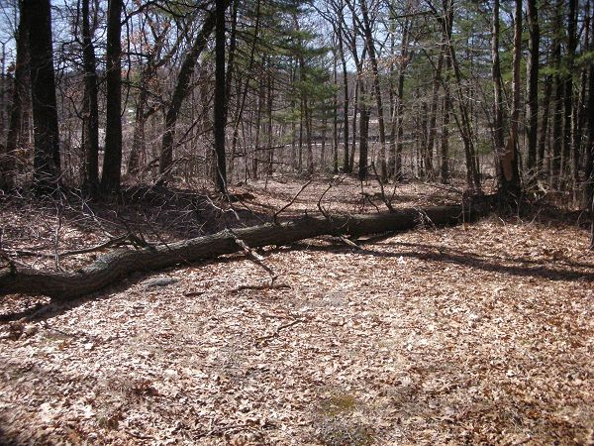

Abbreviations:

Usage type: foot traffic only (H), multi-use (M)

waterbars (wb) small blowdowns (sbd)
culverts(cv) large blowdowns (lbd)
rolling dips (rd) rock work (rkw)
bridges (br) bridge building (bbd),
bog bridges (bb) culvert replacement (cr)
rock stairs (rs) trail relocation (tr),
cribbing (cb) building new trail drainage (ntd)
retaining walls (rw) brushing needed (bn)
ditches (dt) excessive erosion (ee)
leaning tree (lt)

