TRAIL ASSESSMENT FORM

Doc. # | 4011 | Trail Name |  |  | Pine Tree Brook Path North | Trail Type: |  | Wide - M | Condition |  | Good
Route: |  |  | Trailhead from Ridge Path – 4084 – 4073 – HQ Path/Pipeline
Recent Weather: |  |  | Rain last 24 hours, Light rain in the 30’s
TRAIL LANDMARKS |  |  | - Trailhead surveyed is located on the right side (east) of Ridge Path and leaves 40 feet from the Ridge Path trailhead at the fire gate This is a connector path to the main section of Pine Tree Brook Path. Trail is also accessible from Chickatawbut Road as noted on the map although it has not been used very much and is overgrown. Two boulders at the guardrail mark his access. No FBH 4092 intersection marker noted.  - Ridge Path leaves from the north side of Chickatawbut Road at a fire gate and granite marker labeled Ridge Path. It is located .52 miles from the point where the Skyline crosses Chickatawbut Road.  - Trail begins as a connector foot path paralleling Chickatawbut Road.  - Bn at 150 feet.  - Pine Tree Brook Path enters on right at 220 feet to Chickatawbut Road.  - Lbd crosses treadway at 290 feet. Several large limbs need to be removed as treadway bootlegs around limbs. Chainsaw. See photo PTB1. (1)  - Treadway stops paralleling Chickatawbut Road and turns left (NW) at a streambed at 365 feet. Treadway opens to road width at this point.  - Bn at 375 feet. Downed limbs.  - Runoff (3”) in the treadway at 460 feet.  - Bn at .1 miles. Side and overhead.  - Bd crosses the treadway at .12 miles. Needs to be cutback. Bow saw 8”.  - Bd crosses the treadway at .16 miles. Needs to be cutback. Bow saw 8”.  - Treadway crosses an area of runoff at .18 miles entering an intersection.  - Trail enters an intersection at .21 miles. Unnamed path leaves on the right at road width. No intersection marker noted.  - Possible impacted cv under treadway at .21 miles. Runoff entering and exiting under treadway at buried rkw however no evidence of a cv could be found. Needs to be investigated.(2)  - Bn at .22 miles.  - Intersection marker 4084 noted on right side of treadway at .25 miles however no trail exiting on right as noted on the map could be found. Either trail has become obscure or intersection marker moved as noted previously above at an unnamed path. (3) Needs further investigation.  - Cv under treadway at.27 miles for Pine Brook running L to R. Rkw /earthen construction on both sides.  - Bn at .29 miles.  - Sbd in the treadway at .36 miles needs to be pulled off.  - Bn at .36 miles.  - Unnamed path (Great Dome Foot Path FBH) leaves on left at .37 miles at footpath width with bn.  - Two bd cross the treadway at .38 miles and need to be cutback. Bow saw 8”.  - Unnamed path (Great Dome Foot Path FBH) leaves on the right at .43 miles at footpath width. No intersection marker 4073 could be found. (4)  - Small widow maker over treadway at .44 miles. Bow saw 6”.  - Bd crosses at .46 miles. Bow saw 8”. Needs to be cutback.  - Bd w/ pine boughs and bn .47 through .52 miles. Bow saw and loppers.  - Downed limb needs to be removed at .58 miles. 2 people.  - Bn at .60 miles. Downed limb and pine boughs. Rkw wall extends in woods on both sides of treadway.  - Runoff with minor erosion down the center of the treadway at .6 miles. This erosion and runoff continues to the Pipeline intersection. Wb and dt would resolve if desired.  - Downed limbs at .64 miles. 2 people.  - Pine Tree Brook path ends with its intersection with Headquarters Path/ Pipeline at .7 miles. There is a bootleg intersection marker 4049 on a tree to the left of the treadway. (5)
MINOR  PROBLEM  AREAS |  |  | - Lbd crosses treadway at 290 feet. Several large limbs need to be removed as treadway bootlegs around limbs. Chainsaw. See photo PTB1. (1)  - Possible impacted cv under treadway at .21 miles. Runoff entering and exiting under treadway at buried rkw however no evidence of a cv could be found. Needs to be investigated.(2)  - Intersection marker 4084 noted on right side of treadway however no trail exiting on right as noted on the map could be found. Either trail has become obscure or intersection marker moved as noted previously above at an unnamed path. (3) Needs further investigation.  - Unnamed path (Great Dome Foot Path FBH) leaves on the right at .43 miles at footpath width. No intersection marker 4073 could be found. (4)  - Pine Tree Brook path ends with its intersection with Headquarters Path/ Pipeline at .7 miles. There is a bootleg intersection marker 4049 on a tree to the left of the treadway. (5)
MAJOR  PROBLEM AREAS |  |  | - None Noted
DISTANCES TO MAJOR INTERSECTIONS |  |  | - Trailhead from Ridge Path till footpath stops paralleling Chickatawbut Road and turns left (NW) at a streambed - 365 feet.  - Trailhead from Ridge Path to intersection marker 4084 - .25 miles  - Trailhead from Ridge Path to Unnamed path (Great Dome Foot Path FBH) leaves on left - .37 miles.  - Trailhead from Ridge Path to Unnamed path (Great Dome Foot Path FBH) leaves on the right - .43 miles  - Trailhead from Ridge Path to Pine Tree Brook path ends with its intersection with Headquarters Path/ Pipeline - .7 miles.
Report prepared by: |  |  |  | Ken Jones – 3/20/08 |  |  | Assessment date: |  |  | 3/20/2008

PTB1:
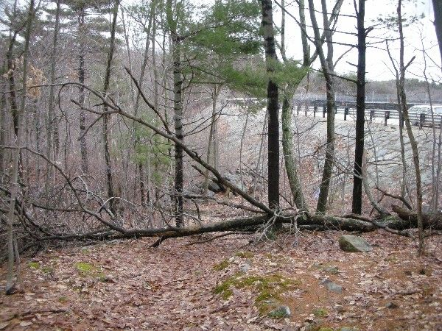

Abbreviations:

Usage type: foot traffic only (H), multi-use (M)

waterbars (wb) small blowdowns (sbd)
culverts(cv) large blowdowns (lbd)
rolling dips (rd) rock work (rkw)
bridges (br) bridge building (bbd),
bog bridges (bb) culvert replacement (cr)
rock stairs (rs) trail relocation (tr),
cribbing (cb) building new trail drainage (ntd)
retaining walls (rw) brushing needed (bn)
ditches (dt) excessive erosion (ee)
leaning tree (lt)

