TRAIL ASSESSMENT FORM

Doc. # | 4012 | Trail Name |  |  | Sassaman Path North | Trail Type: |  | Wide - M | Condition |  | Poor
Route: |  |  | Trailhead from Pasture Run - 4047 – 4048 – 4043 – 4023 - 4042
Recent Weather: |  |  | Rain last 24 hours, Light rain in the 30’s
TRAIL LANDMARKS |  |  | - Sassaman Path leaves from the east side of the Pasture Run Trail approximately 1/8 of a mile north of Chickatawbut Road.  - Bn at 100 feet Debris in treadway.  - Two cut logs in treadway at .15 miles. Remove.  - Treadway enters a 4-way intersection at .17 miles. Intersection not noted on FBH or DCR maps. Intersection created from a not shown, road width connector from Ridge Path to Sassaman Path. Ridge Path enters on right and continues on right while Sassaman Path enters on left and continues left. This intersection should have appropriate signage installed to eliminate confusion. (5)  - Bn at .17 miles.  - Bn at .2 Miles. At this point treadway begins descending into an area of runoff and minor erosion that continues to the Pipeline.  - Bn at .22 miles.  - Ridge Path enters on the right at intersection marker 4047 at .23 miles. Downed limb needs to be removed.  - Bn at .27  - Sassaman Path enters the Pipeline at .29 miles.  - Sassaman re-enters the woods at intersection marker 4048 at .31 miles w/ bn. Unnamed path (TH Headquarters Trail FBH map) exits on left (south)  - (In 2008 the trail section from 4048 to 4023 was closed)  - Dt w/ minor erosion running down the center of the treadway back to the Pipeline at .33 miles.  - Bn at .33 miles.  - Wooded wb at .18 miles. L to R. Ineffective. Needs to be dug out and dt to right.  - Runoff entering the treadway at .36 miles w/ bn.  - Unnamed path (Pleasant Trail FBH map) leaves on right at intersection marker 4043 at .37 miles. Runoff continues.  - Lbd crosses the treadway at .40 miles. Five limbs 8-14”. Chainsaw. (1) Photo SP1.  - Cv under the treadway at .42 miles. Totally impacted and ineffective. Rkw construction on right. No entry noted on left. Runoff goes around cv to the left of treadway and washes back across treadway at a lbd acting as a wb. (2) Photo SP2.  - Lbd w/bn at .47 miles. Cannot locate treadway until around this area. Treadway still in streambed (3) Photo SP3.  - Bn at .48 miles.  - Bn from .49 through .51 miles with numerous bd. Bow saw/loppers.  - Two bd cross the treadway at .51 miles. One can be pulled off and the other needs to be cutback.  - Bn at .53 miles with 4 sbd. (4”) . Side and overhead bn. Bow saw and loppers.  - Cement bunker to the left of the treadway at .55 miles. Area needs to be cleaned up (trash).  - Bn at .56 miles.  - Bn at .59 miles.  - Sbd crosses the treadway at .59 miles. Bow saw.  - Sbd crosses the treadway at .61 miles. Pull off treadway. Bow saw and loppers.  - Bn from .63 through .64 miles. Three Lbd cross the treadway. 24” dia. Chainsaw removal. Can be stepped over. (4) Photo SP4,  - Significant bn at .65 miles. Saplings and bds. Bow saw.  - Sbd crosses treadway at .69 miles. 4” Bow saw.  - Treadway opens to road width beyond the area of major work at .70 miles.  - Trail enters an intersection at intersection marker 4023 at .76 miles. Trial to CCC Camp leaves on the left (west) with CCC Memorial Camp signage with CCC yellow triangular blazing.  - Signage to right of treadway notes this direction (north) to Sawcut Notch Path and Chickatawbut Overlook.  - Cv under the treadway in a streambed at .81 miles. Rkw/earthen construction on both sides through a clay 30” pipe. Flowing well.  - Unnamed path leaves on the right at .82 miles. Connector to Sawcut Notch Path.  - Runoff running down the center of the treadway at .86 miles from Sawcut Notch Path. Current dt to the right of the treadway needs cleaning to resolve.  - Sassaman Path ends with it’s intersection with the to Sawcut Notch Path at intersection marker 4042 at .87 miles. Signage on tree notes Chickatawbut Overlook to the SE and Randolph Ave to the West.
MINOR  PROBLEM  AREAS |  |  | 1. Lbd crosses the treadway at .40 miles. Five limbs 8-14”. Chainsaw. (1) Photo SP1.  4. Bn from .63 through .64 miles. Three Lbd cross the treadway. 24” dia. Chainsaw removal. Can be stepped over. (4) Photo SP4.  5. Treadway enters a 4-way intersection at .17 miles. Intersection not noted on FBH or DCR maps. Intersection created from a not shown, road width connector from Ridge Path to Sassaman Path. Ridge Path enters on right and continues on right while Sassaman Path enters on left and continues left. This intersection should have appropriate signage installed to eliminate confusion. (5)
MAJOR  PROBLEM AREAS |  |  | 2. Cv under the treadway at .42 miles. Totally impacted and ineffective. Rkw construction on right. No entry noted on left. Runoff goes around cv to the left of treadway and washes back across treadway at a lbd acting as a wb. (2) Photo SP2.  3. Lbd w/bn at .47 miles. Cannot locate treadway until around this area. Treadway still in streambed (3) Photo SP3.
DISTANCES TO MAJOR INTERSECTIONS |  |  | - Trailhead to 4 way intersection - .17 miles. Sassaman Path enters on left and continues on left.  - Trailhead to Ridge Path at intersection marker 4047 - .23 miles.  - Trailhead to the Pipeline -.29 miles.  - Trailhead to intersection marker 4048 - .31 miles.  - Trailhead to Unnamed path (Pleasant Trail FBH map) at intersection marker 4043 - .37 miles.  - Trailhead to intersection marker 4023 at .76 miles.  - Trailhead to Sassaman Path ends with it’s intersection with the to Sawcut Notch Path at intersection marker 4042 - .87 miles.
Report prepared by: |  |  |  | Ken Jones – 3/22/08, edited Dexter Robinson - 11/25/09 |  |  | Assessment date: |  |  | 3/20/2008

SP1:

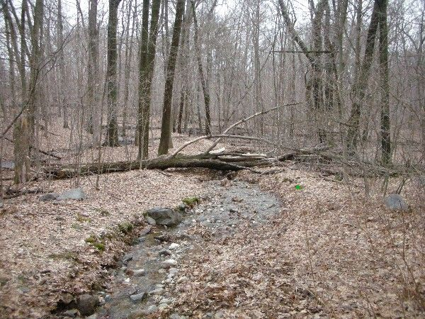

SP2:

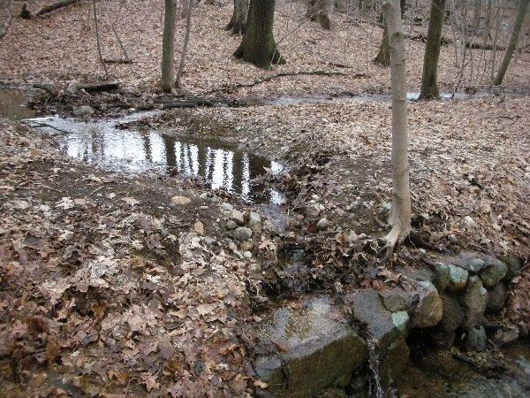

SP3:
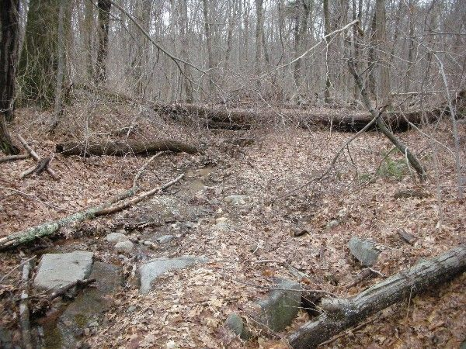

SP4:
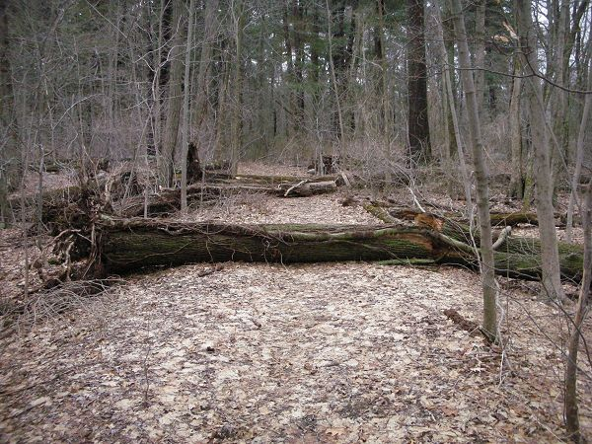

Abbreviations:

Usage type: foot traffic only (H), multi-use (M)

waterbars (wb) small blowdowns (sbd)
culverts(cv) large blowdowns (lbd)
rolling dips (rd) rock work (rkw)
bridges (br) bridge building (bbd),
bog bridges (bb) culvert replacement (cr)
rock stairs (rs) trail relocation (tr),
cribbing (cb) building new trail drainage (ntd)
retaining walls (rw) brushing needed (bn)
ditches (dt) excessive erosion (ee)
leaning tree (lt)

