TRAIL ASSESSMENT FORM

Doc. # | 4017 | Trail Name |  |  | Quarries Foot Path North | Trail Type: |  | Wide and Narrow - M | Condition |  | Good
Route: |  |  | Wampatuck Road - 4238 – 4238 – 4237 – Ricciuti Drive – 4229 – Granite Railroad Historic Site
Recent Weather: |  |  | No rain last 60 hours, Sunny in the 30’s
TRAIL LANDMARKS |  |  | - Trailhead leaves from the west side of Wampatuck Road at a fire gate and granite marker labeled Quarry Foot Path. Trailhead is located approximately .1 mile west of the Bunker Hill/Wampatuck Road intersection. For the most part, this trail is primarily blazed with white rectangles unless otherwise noted in the survey.  - Treadway leaves at road width with bn.  - Cv crosses under the treadway in streambed at 133 feet. Rkw/cement construction w/ 30’ cement pipe. Bn.  - Cv crosses under the treadway at 164 feet. Rkw/cement construction w/ cement pipe. Bn.  - Possible impacted cv under treadway at 232 feet. Evidence in treadway however no pipes were noted. (1)  - Possible impacted cv under treadway at 270 feet. Collapse rwk to right of treadway however no pipes were noted. (2)  - Treadway turns sharp left at 357 feet at private property. Treadway becomes a footpath at this point with bn and debris in treadway.  - Sbd crosses treadway at 430 feet. 8”. Cutback or pull off. 2 people.  - Bd in treadway at .11 miles. 14” chainsaw. Can be stepped over.  - Lbd at .13 miles. Two limbs 18”. Chainsaw. Needs to be cutback. (3) See photo qfp1.  - Bd extending into the treadway at .16 miles. 12”. Cutback. Bn side and overhead.  - Lbd crosses treadway at .22 miles. Previously chain-sawed however more required with extensive bn. (4) See photo qfp2.  - Treadway begins ascending at .23 miles with white blazes.  - Bn at .25. Downed limbs in treadway. Bow saw.  - Treadway turns hard left (West) at .28 miles while scrambling over large granite slabs. Bn.  - Unnamed path leaves on left at .29 miles. To Quincy Auction parking lot eventually.  - Treadway continues to follow the white blazes navigating it’s way around a small quarry to the left of the treadway.  - Bn at .31 miles. Low scrub.  - Unnamed path leaves on left at .32 miles.  - Treadway continues high over granite slabs at .34 miles with a small quarry to the left of treadway continuing to follow white blazes.  - Unnamed path leaves on left at .35 miles at footpath width.  - Treadway begins its descent from the height of land at .38 miles into an area where additional blazing would be helpful. (5)  - Treadway enters an intersection at .44 miles with Quarry Path leaving on the right and an unnamed path leaving on the left.  - Quarry Path leaves on the right at path width at a treed white blaze at .52 miles. Alternate treadway continues straight  - Sbd at .53 miles. 6”. Bow saw.  - White blazes with small retaining wall mark the treadway at .54 miles. At this point blazing continues white rectangles with orange symbols added (circles or rectangles).  - Treadway enters an intersection at road width at .61 miles. Right leads to a large quarry in .02 miles. Left continues with white and orange blazes.  - Unnamed path leaves on left at .66 miles. Quincy Auto Auction lot.  - Treadway enters an intersection at .69 miles. Left fork leads to Quincy Auto Auction area and Ricciuti Drive. Quarry Path continues to right ascending and following white and orange blazes.  - Lbd crosses the treadway as widow maker at .7 miles. Previously chain-sawed with more to be done. (5) See photo qfp3.  - Treadway enters an intersection at intersection marker 4238 at .71 miles. Unnamed path leaves on the left to a crosswalk crossing Ricciuti Drive. Quarry Path follows the fire road width path to the right.  - Bn overhead and side at .72 miles.  - Unnamed path leaves on left to Ricciuti Drive at additional Intersection marker 4328 at .74 miles. (6)  - Two sbd cross the treadway at .76 miles. Bow saw and loppers.  - Unnamed path leaves on the right to quarry at .78 miles.  - Unnamed path leaves on the left at .82 miles at two orange blazes on rock. No additional blazing appears on this trail.  - Downed limb extending into the treadway at .82 miles. Bow saw and loppers.  - Debris in the treadway at .83 miles.  - Unnamed path leaves on the right at .85 miles  - Unnamed path leaves on the right at .89 miles at road width to intersection marker 4236. Marker could not be found however there is a repainted DCR type marker on a tree labeled Tara White. In this location? (7)  - Treadway enters a parking are on the south side of Ricciuti Drive at .93 miles. Much debris in lot to be removed.  - Quarry Foot Path enters Ricciuti Drive at a fire gate at .97 miles.  - Survey follows the sidewalk on the south side the road and crosses Ricciuti Drive across from the Climbers Parking Lot at 1.05 miles.  - Climber’s Parking Lot noted on map is at 1.06 miles.  - Treadway leaves the parking lot at a fire gate on an asphalt road at 1.07 miles.  - Road to right leads to an additional gated parking lot at 1.1 miles.  - Road to left leads into the Quincy Quarries recreational area at 1.14 miles.  - Treadway continues straight leaving the asphalt road and although not marked, continues over a grassy knoll area and descends down a series of granite steps at 1.17 miles returning to a foot path.  - Unnamed path enters on the left 1.18 miles. To Little Granite Quarry.  - Treadway continues over a series of large granite stepping-stones between two large rock outcroppings through some wetland. Unnamed path leaves on left at 1.22 miles. To top of “C” wall climbing area.  - Wooden wb crosses treadway at 1.22 miles. Needs to be dug out (replaced) and dt on right.  - Treadway begins descending to the granite railway at 1.23 miles over a series of granite steps.  - Unnamed path leaves on left at 1.23 miles. Additional path to top of “C” wall climbing area.  - Unnamed path leaves on left to at Bootleg intersection marker 4229 at 1.24 miles. DCR map shows this a wide path however the FBH map shows this as a connector trail to the Quarry Foot Path. (8)  - Significant bn at 1.26 miles. Saplings and downed limbs in the treadway. Loppers.  - Significant side and overhead bn at 1.28 miles  - Treadway steps over two large cut granite blocks and enters the Granite Railway at 1.29 miles.  - Treadway follows to the right of the railway with bn in the railway bed.  - Granite Railway ends at two granite monuments at 1.32 miles and enters the parking and museum area.
MINOR  PROBLEM  AREAS |  |  | - Possible impacted cv under treadway at 232 feet. Evidence in treadway however no pipes were noted. (1)  - Possible impacted cv under treadway at 270 feet. Collapse rwk to right of treadway however no pipes were noted. (2)  - Lbd at .13 miles. Two limbs 18”. Chainsaw. Needs to be cutback. (3) See photo qfp1.  - Lbd crosses treadway at .22 miles. Previously chain-sawed however more required with extensive bn. (4) See photo qfp2.  - Lbd crosses the treadway as widow maker at .7 miles. Previously chain-sawed with more to be done. (5) See photo qfp3.  - Unnamed path leaves on left to Ricciuti Drive at additional Intersection marker 4328 at .74 miles. (6)  - Unnamed path leaves on the right at .89 miles at road width to intersection marker 4236. Marker could not be found however there is a repainted DCR type marker on a tree labeled Tara White. In this location? (7)  - Unnamed path leaves on left to at Bootleg intersection marker 4229 at 1.24 miles. DCR map shows this a wide path however the FBH map shows this as a connector trail to the Quarry Foot Path. (8)  - Editorial Comment – This was a wonderful walk however the continuation of the white rectangular blazes end to end would have made route finding much easier and make for a more enjoyable walk
MAJOR  PROBLEM AREAS |  |  | - None Noted
DISTANCES TO MAJOR INTERSECTIONS |  |  | - Wampatuck Road to Treadway enters an intersection at intersection marker 4238 - .71 miles.  - Wampatuck Road to Ricciuti Drive at a fire gate - .97 miles.  - Wampatuck Road to Ricciuti Drive Climber’s Parking Lot - 1.06 miles  - Wampatuck Road to Bootleg intersection marker 4229 - 1.24 miles.  - Wampatuck Road to Quarry Foot Path ends at the Granite Railway monuments - 1.32 miles.
Report prepared by: |  |  |  | Ken Jones – 3/25/08 |  |  | Assessment date: |  |  | 3/25/2008

Qfp1:

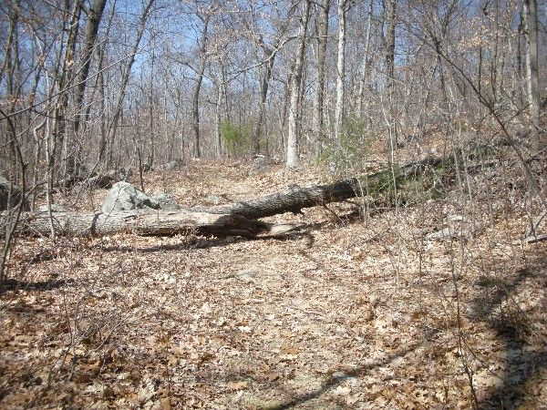

Qfp2:

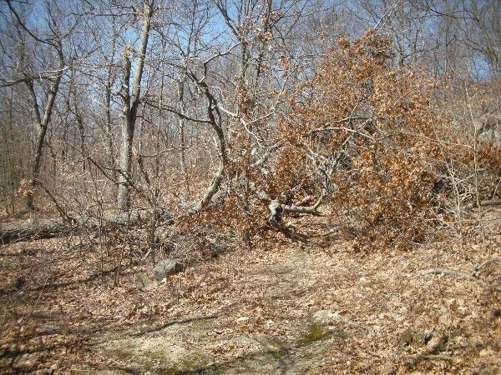

Qfp3:

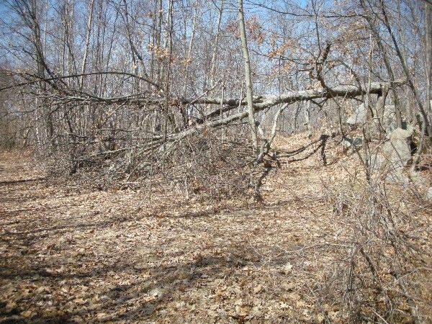

Abbreviations:

Usage type: foot traffic only (H), multi-use (M)

waterbars (wb) small blowdowns (sbd)
culverts(cv) large blowdowns (lbd)
rolling dips (rd) rock work (rkw)
bridges (br) bridge building (bbd),
bog bridges (bb) culvert replacement (cr)
rock stairs (rs) trail relocation (tr),
cribbing (cb) building new trail drainage (ntd)
retaining walls (rw) brushing needed (bn)
ditches (dt) excessive erosion (ee)
leaning tree (lt)

