TRAIL ASSESSMENT FORM

Doc. # | 1012 | Trail Name |  |  | Breakneck Ledge Path North (rev.1) | Trail Type: |  | Wide - M | Condition |  | Good
Route: |  |  | Wolcott Path – 1160 – 1162 – 1178 – 1180 – 1185-Base Bath
Recent Weather: |  |  | Warm - melting snow and ice – Snow cover on trail was 0-3 inches
TRAIL LANDMARKS |  |  | - Trailhead is located on the north side of Wolcott Path, .3 miles west of the Wolcott Path fire gate adjacent to Reservation Headquarters.  - Trail leaves on the right side (north) of Wolcott Path at trail intersection marker 1160.  - Trail blazed with rectangular yellow and triangular yellow direction blazes as noted on map.  - Hancock Hill path leaves on right at 20 feet.  - Overhead bn at 30 feet.  - Wb running L to R at 200 feet. Submerged wood. Dt on R needs cleaning.  - Rd running L to R at 266 feet. Dt on R with lbd in dt blocking flow. Remove. (1)  - Ledge wb running L to R at 367 feet. Dt on right needs cleaning.  - Skyline North trail crosses at intersection marker 1162 at .1 miles.  - Rd running L to R at .17 miles. Dt on right into rkw. Needs cleaning.  - Trail opens up to road width at .17 miles.  - Two very lbd cross treadway at .23 miles. 6-24” Chainsaw removal required, as this is a fire road. Remove. (See photos blp1 and blp2) (2)  - Hemenway Hill Path enters on left (west) at intersection marker 1178 at .38 miles.  - Hemenway Hill Path leaves on right (east) at intersection marker 1180 at .41 miles.  - Treadway continues at road width with bn at .43 miles.  - Bn at .46 miles.  - Cv crosses under treadway at .48 miles. R to L. Rkw/earthen construction with corrugated 24” pipe. Clean dt both sides.  - Cv crosses under treadway at .49 miles in streambed. R to L. Rkw/earthen construction with corrugated 24” pipe. Clean dt both sides.  - Overhead and side Bn at .50 miles.  - Breakneck Ledge path ends with it’s intersection with Base path at intersection marker 1185 at .53 miles.
MINOR  PROBLEM  AREAS |  |  | - Rd with dt on right with lbd in dt blocking flow at 266 feet. Remove.  - Two very lbd cross treadway at .23 miles. 6-24” Chainsaw removal requires, as this is a fire road. Remove. (2) (See photos blp1 and blp2)
MAJOR  PROBLEM AREAS |  |  | None noted
DISTANCES TO MAJOR INTERSECTIONS |  |  | - Wolcott Path marker 1160 to Skyline North intersection marker 1162 - .1 miles.  - Wolcott Path marker 1160 to Hemenway Hill Path enters at intersection marker 1178 at .38 miles.  - Wolcott Path marker 1160 to Hemenway Hill Path leaves at intersection marker 1180 at .41 miles.  - Wolcott Path marker 1160 to Breakneck Ledge Paths ends with its intersection with the Base Path at intersection marker 1185. - .53 miles.
Report prepared by: |  |  |  | Ken Jones Rev1. 4/3/08 |  |  | Assessment date: |  |  | 1/7/2008

BNL1
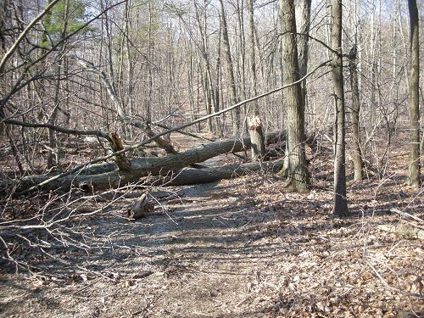

BNL2
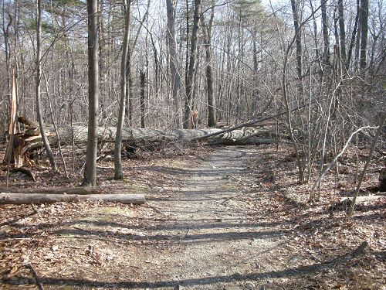

Abbreviations:

Usage type: foot traffic only (H), multi-use (M)

waterbars (wb) small blowdowns (sbd)
culverts(cv) large blowdowns (lbd)
rolling dips (rd) rock work (rkw)
bridges (br) bridge building (bbd),
bog bridges (bb) culvert replacement (cr)
rock stairs (rs) trail relocation (tr),
cribbing (cb) building new trail drainage (ntd)
retaining walls (rw) brushing needed (bn)
ditches (dt) excessive erosion (ee)
leaning tree (lt)

