TRAIL ASSESSMENT FORM

Doc. # | 1015 | Trail Name |  |  | Jeffries Trail North | Trail Type: |  | Narrow - H | Condition |  | Fair
Route: |  |  | Hemenway Hill – Base Path
Recent Weather: |  |  | Warm - melting snow and ice – Snow cover on trail was 0-2 inches
TRAIL LANDMARKS |  |  | - Trailhead leaves the North Skyline trail on the right near the summit of Hemenway Hill.  - Trail is somewhat obscured as it scrambles over the summit ledges into scrub.  - Geocache box 19 located on right at 100 feet.  - Trail is a narrow path with bn 100 – 400 feet.  - Spur trail leaves on right to Hemenway Hill Path east at 434 feet.  - Hemenway Hill Path crosses at .1 miles. Unofficial marker noted on tree at this point labeled 1154 with defaced “no mountain bike” blaze below it.  - Trail continues as a narrow path with bn to .2 miles.  - Bn at .22 miles.  - Lbd or uprooted tree across trail at .3. Remove. SEE PHOTO BELOW.  - Bn from .33 -. 43.  - Trail begins to become obscure at .38 miles. Trees show signs of previous white spot blazing. Needs to be done again. (1).  - Spur trail to nice lookout on left at .47 miles.  - Large fenced in cistern in stream on left downhill at .48 miles.  - Trail crosses stream over rkw bridge at .5 miles. Opened clay pipe sections direct stream under bridge. Possible bog bridge location 20 feet prior to stream. Area was flooded during survey with snowmelt. (2)  - Jeffries Trail ends with its intersection with Base Path at .52 miles.
MINOR  PROBLEM  AREAS |  |  | - Trail obscure at .38 miles. Trees show signs of previous white spot blazing. Needs to be done again.  - Possible bog bridge location 20 feet prior to stream. Area was flooded during survey with snowmelt.  *Significant brushing required on this trail
MAJOR  PROBLEM AREAS |  |  | None noted
DISTANCES TO MAJOR INTERSECTIONS |  |  | - North Skyline Trail to Hemenway Hill Path - .1 miles  - North Skyline Trail to Jeffries trail end at Base Path - .52 miles.
Report prepared by: |  |  |  | Ken Jones |  |  | Assessment date: |  |  | 1/8/2008

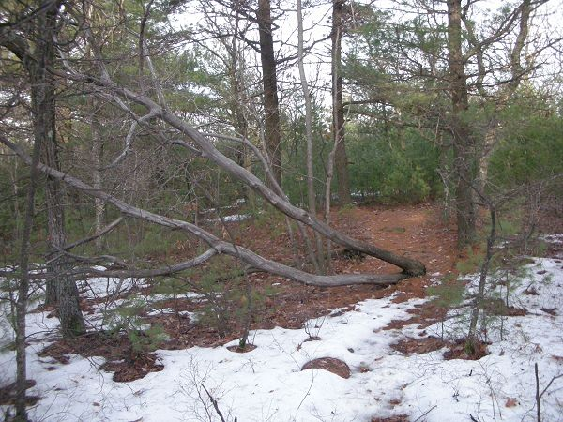

Abbreviations:

Usage type: foot traffic only (H), multi-use (M)

waterbars (wb) small blowdowns (sbd)
culverts(cv) large blowdowns (lbd)
rolling dips (rd) rock work (rkw)
bridges (br) bridge building (bbd),
bog bridges (bb) culvert replacement (cr)
rock stairs (rs) trail relocation (tr),
cribbing (cb) building new trail drainage (ntd)
retaining walls (rw) brushing needed (bn)
ditches (dt) excessive erosion (ee)
leaning tree (lt)

