TRAIL ASSESSMENT FORM

Doc. # | 1024 | Trail Name |  |  | Carberry Path North | Trail Type: |  | Wide - M | Condition |  | Good
Route: |  |  | Walcott Path 1100 – Park Boundry
Recent Weather: |  |  | Rainy today – No snow on trail
TRAIL LANDMARKS |  |  | - Carberry Path trailhead leaves the Border Path on the left, 20 feet north of the Border - Wolcott Path intersection at intersection marker 1100. Intersection is accessed via Wolcott Path east and is .6 miles from the Trailside Museum North parking area.  - Wide treadway turns into a footpath at 100 feet and enters a large meadow at this point.  - Cv crosses under treadway at .1 miles in streambed. Rkw/cinderblock construction on both sides with cement pipe (24”). Streambed is loaded with debris in both wells with tree growing out of streambed on right. Needs cleaning. (1)  - Bn at .16 miles. Apple trees need to be cutback. Bow saw work (2) (See photo below)  - Carberry Path ends at the park boundary and private gate at .18 miles. Private property and residence lies beyond gate.
MINOR  PROBLEM  AREAS |  |  | (1) Cv crosses under treadway at .1 miles in streambed. Cv wells are loaded with debris with tree growing out of well on right. Needs cleaning.  (2) Bn at .16 miles. Apple trees need to be cutback. (Photo attachment CP1)
MAJOR  PROBLEM AREAS |  |  | - None noted
DISTANCES TO MAJOR INTERSECTIONS |  |  | - Trailhead 20 feet north of intersection marker 1100 to Park Boundary - .18 miles
Report prepared by: |  |  |  | Ken Jones |  |  | Assessment date: |  |  | 2/5/2008

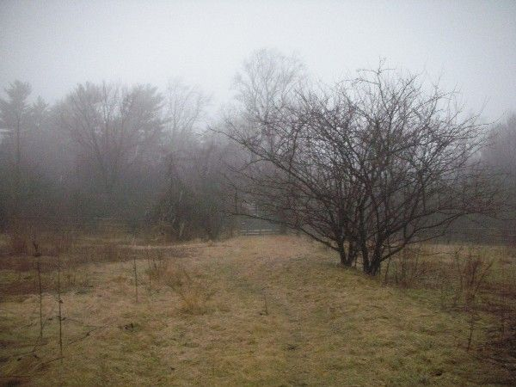

Abbreviations:

Usage type: foot traffic only (H), multi-use (M)

waterbars (wb) small blowdowns (sbd)
culverts(cv) large blowdowns (lbd)
rolling dips (rd) rock work (rkw)
bridges (br) bridge building (bbd),
bog bridges (bb) culvert replacement (cr)
rock stairs (rs) trail relocation (tr),
cribbing (cb) building new trail drainage (ntd)
retaining walls (rw) brushing needed (bn)
ditches (dt) excessive erosion (ee)
leaning tree (lt)

