TRAIL ASSESSMENT FORM

Doc. # | 3003 | Trail Name |  |  | Bouncing Brook Path | Trail Type: |  | M | Condition |  | Good
Route: |  |  | From ‘y’ at Squamaug Notch Path to gate at rte.28
Recent Weather: |  |  | Clear, no precipitation in at least a week
TRAIL LANDMARKS |  |  | Trail starts apparently at a ‘y’ intersection with Squamaug Notch Path, between 3163 and 3152, and travels generally E and SE. Easiest access is from Wood Road, via Romari Trail and Squamaug Notch Path.  Starting from the ‘y’:  10 yd Partial lbd(1)  150 yd Lg. lt (2)  160 yd sm lt(3)  230 yd 3152 with Wampatuck Path  261yd 3151 right at ‘y’ missing mk(4)  272 yd S side of trail du  354 yd old nf wb not really needed not an obstruction  502 yd 3130 int Curve (trail?path?no desig.on map)on right part of red dot loop—red dots are new and visible on BB trail  529 yd 12” corr plastic cv (5)  539 yd nf wb(not an obst) (6)  578yd 24” cp cv fc(7)  .58 mi nf wb(nn)(not an obstruction)  .59 mi 3085(mk need new)nf cv(8)  .60 mi nf armored water crossing (9)  .61 nf wb rr tie (10)  .62 3073 int w/ Side Notch Path on N side  .64 int w/Lee Path (11)  .64 ditch on N side leading W into 12” cp cv (12) (Swamp/vernal area on S side of trail)  .68 N side large du (13)  .70 fc cl cv with swamp/vernal N/S sides of trail mostly standing water(14)  .81 hemlock grove no mk(15) trail forks left  .82 int with Braintree Pass Path, turning uphill in SW direction  .82 same int. nf cl cv old stone-armored, mortared 12” nf cp cv(16)  .87 nf cl cv (17)  .88 int with Slide Hill Trail (18)  .88 nf cl cv (19)  1.02 mi int. w/Pipe Line Trail  1.05 mi. gate at rte 28 with granite marker ‘Bouncing Brook’  --also at this point a ‘ no wheeled vehicles’ sign on a tree, facing the road
MINOR  PROBLEM  AREAS |  |  | Trail itself needs no work. Is wide enough and accessible enough for vehicle passage. No cutbacks necessary at this time, but may need sapling cutbacks in some places in 2-3 years to maintain width.  A lot of culvert and ditch cleaning needed that could be done in sections by crews of 2-3 people. Not heavy work, just need fire rakes, shovels, maybe a pick, and wheel barrow for removed duff and leaves.  (4) mk replacement  (5) cv clogged with leaves. Needs cleanout  (6) minor rkw not a high priority, but could replace the nf wb  (7) ditch leading up to needs cleaning out  (8) hidden/no pipe visible, need dig out for proper fc  (11) no mk-recommend one  (12) need clean out all  (14) cv needs cleaning out. trail puddles here in wet seasons, need to trench out the sides of trail to drain  (15) need mk  (16) needs cleaning along with ditches leading up to  (17) needs cleaning along with ditches leading up to  (18) no mk, may be 3023?  (19) needs cleaning along with ditch on S side
MAJOR  PROBLEM AREAS |  |  | - chainsaw  - chainsaw –hard hats  - chainsaw and manually move  (9) needs more rkw and ntd heavily silted both sides  (10) rotted needs replacing and ditch leading to needs cleaning  (13) lg dead trees on top edge that will fall onto trail 1-2 years
DISTANCES TO MAJOR INTERSECTIONS |  |  | Trail length 1.05 mi.
Report prepared by: |  |  |  | Steve Cobble |  |  | Assessment date: |  |  | 01/09/08

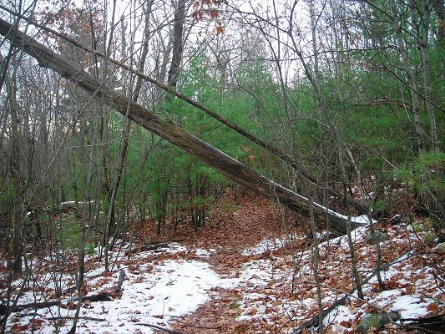

Abbreviations:

Usage type: foot traffic only (H), multi-use (M)

waterbars (wb) small blowdowns (sbd)
culverts(cv) large blowdowns (lbd)
rolling dips (rd) rock work (rkw)
bridges (br) bridge building (bbd),
ditches (dt) corrugated plastic(cp)
excessive erosion (ee) leaning tree (lt))
intersection marker(mk) dugout(du)
bog bridges (bb) culvert replacement (cr)
non-functioning(nf) functioning(fc)
not needed(nn)
rock stairs (rs) trail relocation (tr),
cribbing (cb) building new trail drainage (ntd)
retaining walls (rw) brushing needed (bn)
clay(cl)

