TRAIL ASSESSMENT FORM

Doc. # | 6001 | Trail Name |  |  | Indian Path South | Trail Type: |  | Narrow - M | Condition |  | Good
Route: |  |  | Fowl Meadow Path To Burma Road
Recent Weather: |  |  | Light snow in last 24 hours, 0-1/2 on trail. Sunny and 18 degrees
TRAIL LANDMARKS |  |  | - The Indian Path trail leaves from the north west end of the Fowl Meadow Path turning south on the south bank of the Neponset River. The trail leaves at footpath width and is noted as an unnamed trail on the latest DCR map. The DCR map shows it as a footpath heading south paralleling the south bank of the Neponset river to its intersection with Burma Road. This is a wonderful walk along the river ascending and descending slightly as it follows the contours of tributaries flowing into the Neponset River. Commuter rail follows the north side of the river.  - This trail also continues north of the Fowl Meadow Path following the Neponset River however is not shown on the DCR map.  - Treadway crosses a small stream at 230 feet. 3” wide.  - Treadway crosses a small stream at 370 feet. 3” wide.  - Minor Bn at 1.7 miles.  - Sbd crosses the treadway at .2 miles. Bow saw work.  - Bd crosses the treadway at .23 miles. 4” diameter. Can be stepped over. Removal discretionary.  - Bn at .29 miles. Overhead branches with debris on ground needing to be pulled back from treadway.  - Limb overhanging treadway at .35 miles. 2” dia. Too low for bikers and tall people.  - Dead limb protruding from treadway at .44 miles. Obstructed view. Could pose a safety issue to bikers and should be removed. Bow saw work. Photo IP1 attached. (1)  - Bn at .48. Saplings encroaching into treadway.  - Bn at .57. Saplings encroaching into treadway.  - Downed limb crosses treadway at .58 miles. 8” diameter. Can be stepped over. Can be carried off by 2 people.  - Bn at .60 miles. Saplings encroaching as well as low limbs into treadway.  - Bd crosses treadway at .65 miles. 10” dia. Can be stepped over. Discretionary removal for mountain bikers.  - Bn at .73 miles.  - Bd crosses treadway at .77 miles. !0” dia. Can be stepped over. Discretionary removal for mountain bikers.  - Bn at .87 miles. Side and overhead.  - Bd extending partially into the treadway at 1.0 miles.  - Large limbs over treadway at 1.06 miles at 6’. Discretionary removal for mountain bikers.  - The Indian Path leaves left from the footpath following the riverbank at 1.1 miles and continues on to Burma Road.  - The small footpath continues to follow the river for another .2 miles and ends at a small stream just before the route 95 underpass.  - Indian Path ends with its intersection with Burma road at 1.15 miles.
MINOR  PROBLEM  AREAS |  |  | - Dead limb protruding from treadway at .44 miles. Obstructed view. Could pose a safety issue to bikers and should be removed. Bow saw work. Photo ST1 attached.
MAJOR  PROBLEM AREAS |  |  | - None noted
DISTANCES TO MAJOR INTERSECTIONS |  |  | - Fowl Meadow Path To Burma Road - 1.15 miles
Report prepared by: |  |  |  | Ken Jones – 12/10/2008 |  |  | Assessment date: |  |  | 12/8/2008

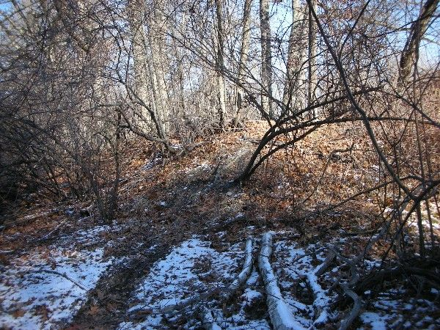

Abbreviations:

Usage type: foot traffic only (H), multi-use (M)

waterbars (wb) small blowdowns (sbd)
culverts(cv) large blowdowns (lbd)
rolling dips (rd) rock work (rkw)
bridges (br) bridge building (bbd),
bog bridges (bb) culvert replacement (cr)
rock stairs (rs) trail relocation (tr),
cribbing (cb) building new trail drainage (ntd)
retaining walls (rw) brushing needed (bn)
ditches (dt) excessive erosion (ee)
leaning tree (lt)

