TRAIL ASSESSMENT FORM

Doc. # | 5016 | Trail Name |  |  | Smith Trail East | Trail Type: |  | Narrow - H | Condition |  | Poor
Route |  |  | 5425 – High Street
Recent Weather: |  |  | Dry last 24 hours, Party Sunny in the 40’s
TRAIL LANDMARKS |  |  | - Trail: leaves the Pipeline on the right (east) at intersection marker 5425 at path width. Trailhead is .65 miles north of the Horse Bridge connector at the Pipeline intersection.  - Trail is sloppily blazed with gold spray paint in its entirety. Having said this, without the poor blazing job the route would be impossible to follow. This trail gets very little use and is quite overgrown. Recommend proper and additional blazing as route fining is difficult. (1)  - Bn immediately leaving the trailhead.  - Two lbd cross at 20 feet. Can be stepped over.  - Bd crosses at 50 feet. Can be stepped over.  - Bd crosses at 100 feet with another that needs to be walked around. Cut back.  - Side and overhead bn at 310 feet.  - Three lbd cross the treadway between 320 through 370 feet. Can be stepped over.  - Two sbd cross the treadway at 395 feet with bn. Can be stepped over.  - Sbd crosses the treadway at .11 miles. Can be stepped over.  - Lbd crosses the treadway at .13 miles. Four large limbs. Difficult to step over. Should be cut back. (3) See photo st1.  - Overhead bn at .15 miles. Branches.  - Bd crosses the treadway at .16 miles with significant bn. Blazes scarce and trail lost. Had to backtrack to pick up trail.  - Bn continues through .18 miles.  - Overhead and side bn from .20 through .22 miles.  - Bn at .24 miles with route finding difficult. Had to backtrack to pick up trail.  - Bn from .27 through .28 miles.  - Treadway enters a well worn path at .28 with bn.  - Lbd with bn at .29 miles. Can be stepped over.  - Treadway begins ascending at .32 miles and reaches a height of land at .35 miles at a large boulder.  - Bn from .39 through .40 miles.  - Treadway turns sharp right (south) at .42 miles.  - Treadway begins to open up at .45 miles.  - Bn at .46 miles. Pine boughs.  - Bn at .48 miles. Low scrub.  - Smith Trail ends with its intersection with High Street at .52 miles. Lantana’s parking are is across the street.
MINOR  PROBLEM  AREAS |  |  | - Trail is sloppily blazed with gold spray paint in its entirety. Having said this, without the poor blazing job the route would be impossible to follow. This trail gets very little use and is quite overgrown. Recommend proper and additional blazing as route finding is difficult. (1)  - Significant brushing as noted in the assessment.  - Lbd crosses the treadway at .13 miles. Four large limbs. Difficult to step over. Should be cut back. (3) See photo st1.
MAJOR  PROBLEM AREAS |  |  | - None noted
DISTANCES TO MAJOR INTERSECTIONS |  |  | - Trailhead at 5425 to the Smith Trail ends at its intersection with High Street - .52 miles.
Report prepared by: |  |  |  | Ken Jones – 4/26/08 |  |  | Assessment date: |  |  | 4/21/2008

ST1:

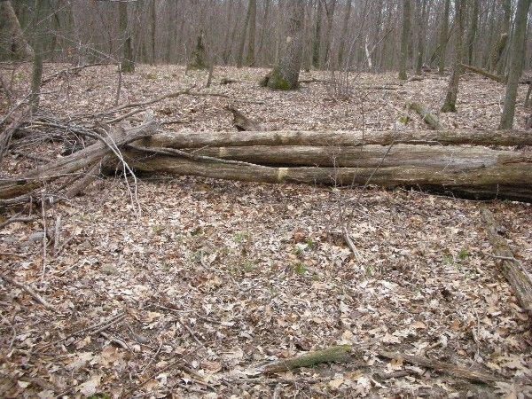

Abbreviations:

Usage type: foot traffic only (H), multi-use (M)

waterbars (wb) small blowdowns (sbd)
culverts(cv) large blowdowns (lbd)
rolling dips (rd) rock work (rkw)
bridges (br) bridge building (bbd),
bog bridges (bb) culvert replacement (cr)
rock stairs (rs) trail relocation (tr),
cribbing (cb) building new trail drainage (ntd)
retaining walls (rw) brushing needed (bn)
ditches (dt) excessive erosion (ee)
leaning tree (lt)

