TRAIL ASSESSMENT FORM

Doc. # | 4001 | Trail Name |  |  | Skyline Trail West Shea Rink to Chickatawbut Road | Trail Type: |  | Wide - M | Condition |  | Good
Route: |  |  | Shea Rink – Wampatuck Road – 4214 - 4184 – 4174 – 4155 – Chickatawbut Road
Recent Weather: |  |  | Rainy yesterday - Snow today – 0-1/2” snow on trail
TRAIL LANDMARKS |  |  | - The trailhead is located at the south end of the Shea Rink parking area at the Blue Hills Reservation information board. Trail is primarily blazed with blue rectangular blazes however leaving the trailhead it is additionally blazed with green circles.  - Bn immediately into the woods. Briars encroaching.  - Unnamed Path enters on the left at 200 feet through a rock wall out to Willard Street.  - Unnamed Path leaves on the right at 265 feet.  - Bn at 420 feet. Blazes have graffiti.  - Unnamed Path leaves on the left at 520 feet.  - Treadway climbs to .1 miles with a nice view of the St. Moritz Ponds.  - Unnamed Path enters on the left at .15 miles  - Treadway enters a clearing at .18 miles just east of the St. Moritz Pond footbridge where an unnamed path enters on the right and an additional unnamed path crosses.  - Treadway crosses the footbridge at .19 miles.  - Unnamed Path leaves on the right at .27 miles.  - Treadway enters a clearing at .3 miles where a fire road crosses and an additional unnamed road leaves on the left.  - Rd at .3 miles. L to R. Dt on left but not on right causing minor erosion. Should be dt on right (1).  - Crags Foot Path ( Green Dot blazed) leaves on left at .31 miles.  - Trail crosses Wampatuck Road at the fire gate at .32 miles.  - Trail re-enters the woods at a fire gate and granite marker labeled Quarry Trail Footpath on one side and Skyline Trail 7.9 miles  on the other side.  - Unnamed Path leaves on the right at .35 miles.  - Sawcut Notch Path leaves on the right at intersection marker 4214 at .39 miles.  - Treadway turns into footpath width at this point.  - Lbd crosses the treadway at .49 miles. Bootleg trail navigates its way around site. Should be removed. (Chainsaw) (2) (See photo slwampa1)  - Unnamed Path enters on the left at .49 miles.  - Crags Foot Path enters on the left at intersection marker 4184 at .6 miles. Crags Foot and the Skyline use the same treadway for .1 miles as the treadway opens to a wide path with additional green dot blazes.  - Crags Foot Path leaves on the right (green dots) at intersection marker 4174 at .7 miles.  - Skyline Trail returns to foot path width.  - Bn .71 -.72 miles.  - Treadway turns left at abandoned water filled quarry site at .73 miles.  - Rwb at .74 miles. L to R. Dt into quarry pond.  - Unnamed Path enters on the left at .74 miles as treadway navigates around quarry pond.  - Unnamed Path enters on the left at .79 miles.  - Bn at .79 miles.  - Bn at .87 miles as trail begins to ascend Rattlesnake Hill on rock steps.  - Short unnamed path leaves on left to Rattlesnake Hill summit at .88 miles.  - Treadway goes over Rattlesnake Hill and begins a steep descent at .88 miles. Bootleg trail leaves on right to avoid steep decent and looks like it’s quite used.  - Rattlesnake Hill descent ends in an area of runoff at .94 miles. Today this area was a riverbed as is also the case in the spring. Consideration should be given to locate a bog bridge in this area. (3) (See photo slwampa2)  - Indian Camp Path (green dots) crosses at intersection marker 4155 at .96 miles.  - Underground pipeline goes under treadway at .96 miles  - Skyline Trail crosses another area of significant runoff at 1.0 miles. Consideration should be given to locate a bog bridge in this area. (4) (See photo slwampa3)  - Sbd at 1.04 miles. Bow saw and bn work.  - Bn at 1.05 miles for 100 yards.  - Pond on right at 1.05 miles.  - Bn at 1.1 miles.  - Trail ascends into an area of minor erosion at 1.1. Could use wb to minimize.  - Bn at 1.13 miles.  - Treadway crosses the summit of Wampatuck Hill at 1.18 miles.  - Bn at 1.18 miles for 100 yards.  - Unnamed Path leaves on the right at 1.18 miles.  - Bn from 1.23 – 1.30 miles.  - Limb across trail at 1.32 miles needs to be cut back. Bow saw work.  - Trail crosses Chickatawbut Road at a fire gate and granite marker at 1.35 miles. Marker labeled Wampatuck Hill 353 feet. Intersection also provides signage on trees for Skyline Trail East to St. Moritz and DCR map board. No MB signage on both paths.
MINOR  PROBLEM  AREAS |  |  | (1) Rd at .3 miles. L to R. Dt on left but not on right causing minor erosion. Should be dt on right to reduce erosion.  (2) Lbd crosses the treadway at .49 miles. Bootleg trail navigates its way around site. Should be removed. (Chainsaw) (2) (See photo slwampa1)  (3) Rattlesnake Hill descent ends in an area of runoff at .94 miles. Consideration should be given to locate a bog bridge in this area. (3) (See photo slwampa2)  (4) Skyline Trail crosses another area of significant runoff at 1.0 miles. Consideration should be given to locate a bog bridge in this area. (4) (See photo slwampa3)
MAJOR  PROBLEM AREAS |  |  | - None noted
DISTANCES TO MAJOR INTERSECTIONS |  |  | - Shea Rink parking lot to Wampatuck Road - .32 miles.  - Shea Rink parking lot to Sawcut Notch Path at intersection marker 4214 - .39 miles.  - Shea Rink parking lot to Crags Foot Path enters at intersection marker 4184 - .6 miles.  - Shea Rink parking lot to Crags Foot Path leaves at intersection marker 4174 - .7 miles.  - Shea Rink parking lot to Indian Camp Path at intersection marker 4155 - .96 miles.  - Shea Rink parking lot to Chickatawbut Road - 1.35 miles.
Report prepared by: |  |  |  | Ken Jones |  |  | Assessment date: |  |  | 2/7/2008

Slwampa1
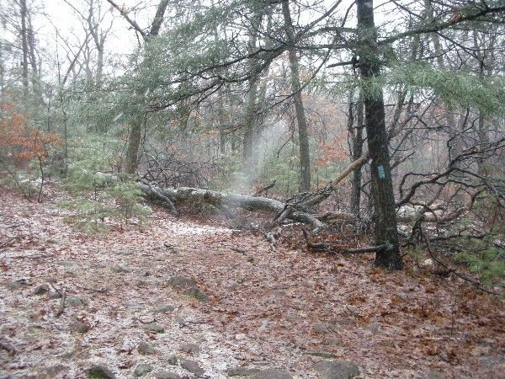

Slwampa2
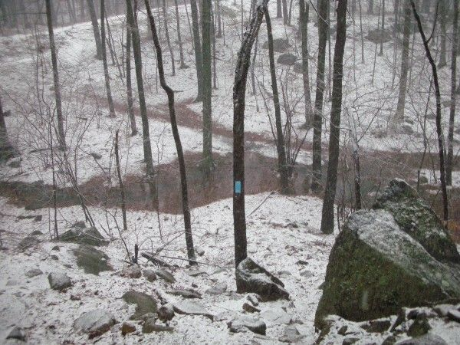

Slwamp3
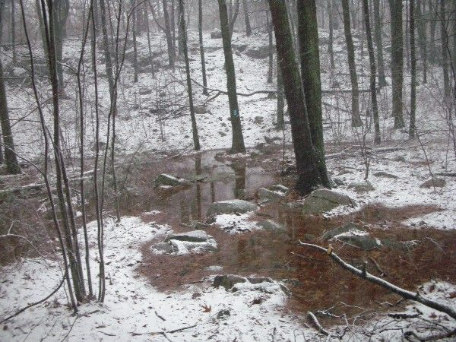

Abbreviations:

Usage type: foot traffic only (H), multi-use (M)

waterbars (wb) small blowdowns (sbd)
culverts(cv) large blowdowns (lbd)
rolling dips (rd) rock work (rkw)
bridges (br) bridge building (bbd),
bog bridges (bb) culvert replacement (cr)
rock stairs (rs) trail relocation (tr),
cribbing (cb) building new trail drainage (ntd)
retaining walls (rw) brushing needed (bn)
ditches (dt) excessive erosion (ee)
leaning tree (lt)

