TRAIL ASSESSMENT FORM

Doc. # | 4005 | Trail Name |  |  | Green Dot Loop – Shea Rink to Skyline Trail | Trail Type: |  | Wide - M | Condition |  | Good
Route: |  |  | Shea Rink – 4205 - 4202 – Wampatuck Rd.– 4155 – 4135 – 4120 – 4090 – 4095 – 4142 – 4145 – 4151 – 4174 – 4184 - Wampatuck Rd – Skyline Trail.
Recent Weather: |  |  | No rain last 48 hours, Sunny in the 40’s
TRAIL LANDMARKS |  |  | - The Green Dot trail is a loop trail utilizing many trails in the 4000 section of the Blue Hills. The Indian Camp Path and Crags Foot Path are the primary trails however there are many other sections of older trails noted on granite markers and the old FBH maps. They will be noted in the assessment, as I feel pertinent.  - The trailhead is located at the south end of the Shea Rink parking area at the Blue Hills Reservation information board. Trail is blazed with green circles however leaving the trailhead it is additionally blazed with blue rectangular blazes as it shares the same treadway as the Skyline Trail West.  - Green Dot Trail leaves the Skyline Trail on the left at 473 feet. Treadway is footpath width. Additional blazing and signage required at this intersection, as the treadway is not blazed until .11 mile (1).  - Treadway crosses streambed over Minichiello Bridge at .13 miles. Signage to right of treadway identifies it. Bridge missing approximately a dozen treads. Replace (2)  - Unnamed path leaves on right around the east side of South St. Moritz Pond.  - Treadway ascends to an underground pipeline with a cv running under the pipeline to the right of the treadway at .22 miles. Cement construction. Water from cv is being directed onto the treadway and down into South St. Moritz Pond. Ditching should be incorporated to resolve this issue. (3)  - Green Dot enters an intersection with the Pipeline crossing at .23 miles. Green Dot Trail turns left (south) at this intersection and parallels the pipeline at fire road width. An unnamed path continues straight. Signage on tree notes the direction to the St. Moritz Ponds. Intersection marker 4205 as noted on map could not be located and should be replaced (4)  - Green Dot Blaze noted on pipeline standpipe at .26 miles. Most other blazes on the pipeline are located on 4x4s adjacent to the treadway.  - Cv under treadway at .3 miles. Cement construction with rkw wells and 24” pipe.  - Unnamed Path leaves on right at .32 miles. Connector to Murphy’sPath/ Trail.  - Cv under treadway at .34 miles. Cement construction with rkw wells and 24” pipe. Treadway ascends over earthen bridge with railings and blaze post. Pipeline continues to parallel treadway.  - Cv under treadway at .38 miles. Cement construction with rkw wells and 24” pipe.  - Cv under treadway at .40 miles. Cement construction with rkw wells and drainage structure to right of treadway.  - Green Dot Blaze noted on pipeline standpipe at .42 miles.  - Unnamed Path leaves on right at .47 miles with intersection marker 4202 noted in magic marker on 4x4 blaze post. Should be of the standard intersection marker construction. (5)  - Cv under treadway in streambed at .38 miles. Cement construction with rkw wells. Flowing well. Review in spring.  - Unnamed Path leaves on left at .58 miles. This is the Indian Camp Trail from the old FBH maps. Intersection marker 4125 not present and trail is very overgrown. Blue wooden blaze on tree.  - Treadway enters Wampatuck Road and crosses it diagonally to the left at .71 miles. 4x4 blaze post with magic marker noting 4181 at this location.  - Treadway renters the woods at a fire gate and granite marker labeled Chimney Crags at .75 miles. Fire gate is .7 miles south of the reservation entrance on Wampatuck Road.  - Treadway continues at fire road width and continues to parallel the pipeline.  - Sbd across the treadway at .91 miles. 4”. Bow saw.  - Cv to the left of the treadway at .92 miles under pipeline. Cement construction with 2 pipes half full of debris. Water not draining and treadway has 2’ of water on it. Needs to be dt into woods on right. (6) (see photo gd1)  - Skyline crosses at intersection marker 4155 at .97 miles. Signage on tree denotes Skyline West to Great Blue Hill and Green Dot to St. Moritz Ponds.  - Lbd across treadway at 1.0 miles. 8” dia. Chainsaw. Blocking Fire road. (7) (See photo gd2)  - Cv to the left of the treadway at 1.03 miles under pipeline. Cement construction with 2 pipes half full of debris. Water not draining and treadway has 2’ of water on it. Needs to be dt into woods on right.  - Fire road partially blocked by new tree growth at 1.05 miles. Cut back.  - Cv to the left of the treadway at 1.11 miles under pipeline. Cement construction with 2 pipes half full of debris. Water not draining and treadway has 2’ of water on it. Needs to be dt into woods on right.  - Bn at 1.12 miles.  - Unnamed path leaves on left at 1.13 miles.  - Cv under treadway at 1.14 miles. Cement work to right of treadway.  - Cv to the left of the treadway at 1.16 miles under pipeline. Cement construction totally impacted. Treadway has 2’ of water on it. Needs to be dt into woods on right.  - Pipeline Trail crosses at intersection marker 4135 at 1.17 miles.  - Bn at 1.19 miles. Lopper work.  - Bn needed 1.28 through 1.34 miles.  - Cv under treadway in streambed at 1.37 miles. 24” clay pipe. Debris in rkw well on R and L to be cleaned.  - Unnamed path leaves on right at intersection marker 4120 at 1.38 miles. Road width connector to Crags Foot Path. Old FBH maps show this as the Furnace Brook Trail.  - Bn from 1.39 to 1.71 miles. Small trees extending into treadway.  - Very minor erosion ascending hill at 1.5 miles.  - Unnamed path enters on left at 1.64 miles. Road width path to Fox Hill.  - Two inches of standing water in treadway at 1.65 miles  - Unnamed path leaves on left at 1.73 miles. Great Dome Foot Path as noted on old FBH maps.  - Treadway enters an intersection at intersection marker 4090 at 1.75 miles. Signage on tree denotes the Green Dot trail leaving on a footpath to the right (northeast). Indian Camp Path continues straight (northwest) at road width to intersection marker 4083 as noted on old FBH maps. Pleasant Trail leaves on the left at road width to intersection marker 4043 as noted on old FBH maps.  - Green Dot trail leaves intersection 4090 on the right (northeast) at 1.75 miles at footpath width. Old FBH maps show this trail as a continuation of the Great Dome Foot Path northeast. Significant cleanup to be completed for next .15 miles (8)  - Bn at 1.75 miles.  - Bd extends into the treadway at 1.78 miles. Needs to be cutback. Bow saw.  - Bd crosses the treadway at 1.78 miles with bn. Bow saw 4-8”.  - Lbd crosses the treadway at 1.79 miles. Three limbs. Bow saw.  - Bn at 1.80 through 1.82.  - Bd crosses the treadway at 1.82 miles. 10” Bow saw or axe.  - Bd crosses the treadway at 1.84 miles with bn. 8” Bow saw.  - Crags Foot Path enters on left at intersection marker 4095 at 1.90 miles. At this point the treadway returns to road width with the Green Dot Trail and Crags Foot Path sharing the same treadway. Green dot blazes continue to identify the trail.  - Bn from 2.02 through 2.22 miles. Small trees extending into the treadway.  - Downed limb at 2.08 miles with bn. 8’. Bow saw and loppers.  - Short Path leaves on left at 2.11 miles. Old intersection marker 4124H in noted at this location. Old FBH maps note this as well.  - Cv under treadway in streambed at 2.32 miles. R to L. Rkw/earthen construction. 30” pipe. Flowing well with minor cleaning required.  - Unnamed path leaves on right at intersection marker 4142 at 2.36 miles. Road width connector to Indian Camp Path. Old FBH maps show this as the Furnace Brook Trail.  - Runoff in treadway at 2.41 miles. Treadway should be have a rkw dt with appropriate dt into woods installed to resolve. (9)  - Old Furnace Brook Path leaves on left at intersection marker 4155 at 2.45 miles.  - Bn at 2.51 miles  - Unnamed path leaves on the right at intersection marker 4151 at 2.54. Treadway is road width. Old FBH maps show this as Crags Foot Path leaving to the Indian Camp Trail. The Quarry Path begins here and shares the same treadway with the Green Dot Trail.  - Unnamed path leaves on the right at 2.58.  - Bn at 2.62 miles.  - Unnamed path leaves on the right at 2.68.  - Unnamed path leaves on the right at 2.71.  - Two rkw wb cross at 2.73 and 2.74 miles. R to L. Need cleaning, add missing rock and dt on left installed.  - Skyline enters on the right at intersection marker 4174 at 2.79 miles. For the next .9 miles, the Green Dot, Quarry Path and the Skyline use the same treadway. (4172 old FBH map)  - Green Dot/Quarry Path leaves the Skyline at intersection marker 4184 at 2.88 miles. Treadway narrows to a footpath at this point.  - Bn from 2.9 through 2.92 miles.  - Unnamed path enters on the right at 2.94 miles.  - Wampatuck Road crosses at 2.97 miles at a fire gate and a granite marker labeled Quarry Path.  - Green Dot/Quarry Path reenters the woods on the east side of Wampatuck Road at 2.98 miles.  - Rkw Cv under Wampatuck Road enters to the left of the treadway at 3.0 miles. 2 pipes with drainage from cv causing minor erosion.  - Lbd crosses at 3.03 miles acting as wb in wrong direction. Needs to be cut back. (old).  - Lbd crosses at 3.1 miles. Needs to be cut back. (old).  - Bn at 3.12 miles.  - Green Dot/Quarry Path ends with its intersection with the Skyline Trail at 3.14 miles just south of Wampatuck Road.
MINOR  PROBLEM  AREAS |  |  | - Green Dot Trail leaves the Skyline Trail on the left at 473 feet. Additional blazing and signage required at this intersection, as the treadway is not blazed until .11 mile (1).  - Treadway crosses streambed over Minichiello Bridge at .13 miles. Bridge missing approximately a dozen treads. Replace (2)  - Cv running under the pipeline to the right of the treadway at .22 miles. Water from cv is being directed onto the treadway and down into South St. Moritz Pond. Ditching should be incorporated to resolve this issue. (3)  - Green Dot enters an intersection with the Pipeline crossing at .23 miles. Green Dot Trail turns right (south) at this intersection. Intersection marker 4205 as noted on map could not be located and should be replaced (4)  - Unnamed Path leaves on right at .47 miles with intersection marker 4202 noted in magic marker on 4x4 blaze post. Should be of the standard intersection marker construction. (5)  - Cv to the left of the treadway at .92 miles under pipeline. 2 pipe half full of debris. Water not draining and treadway has 2’ of water on it. Needs to be dt into woods on right. (6) (see photo gd2)  - Lbd across treadway at 1.0 miles. 8” dia. Chainsaw. Blocking Fire road. (7) (See photo gd1)  - Green Dot trail leaves intersection 4090 on the right (northeast) at 1.75 miles at footpath width. Significant cleanup to be completed for next .15 miles (8)  - Runoff in treadway at 2.41 miles. Treadway should have a rkw dt with appropriate dt into woods installed to resolve. (9)
MAJOR  PROBLEM AREAS |  |  | - None noted
DISTANCES TO MAJOR INTERSECTIONS |  |  | - Shea Rink parking lot to Pipeline at intersection marker 4205 - .23 miles. Replaced missing marker (4)  - Shea Rink parking lot to Unnamed Path leaves on right at intersection marker 4202 - .47 miles. Magic marker on 4x4 blaze post (5)  - Shea Rink parking lot to Wampatuck Road - .71 miles.  - Shea Rink parking lot to Skyline at intersection marker 4155 - .97 miles.  - Shea Rink parking lot to Pipeline Trail at intersection marker 4135 - 1.17 miles.  - Shea Rink parking lot to Unnamed path leaves on right at intersection marker 4120 - 1.38 miles. Furnace Brook Trail on old FBH map  - Shea Rink parking lot to intersection marker 4090 - 1.75 miles. Green Dot. Indian Camp Path N. and Pleasant Trail noted on old FBH maps.  - Shea Rink parking lot to Crags Foot Path at intersection marker 4095 - 1.90 miles.  - Shea Rink parking lot to Short Path - 2.11 miles.  - Shea Rink parking lot to unnamed path at intersection marker 4142 - 2.36 miles. Furnace Brook Trail on old FBH maps.  - Shea Rink parking lot to Old Furnace Brook Path at intersection marker 4155 - 2.45 miles.  - Shea Rink parking lot to unnamed path at intersection marker 4151 - 2.54. Crags Foot Path on old FBH map.  - Shea Rink parking lot to Skyline at intersection marker 4174 - 2.79 miles.  - Shea Rink parking lot to Green Dot/Quarry Path leaves the Skyline at intersection marker 4184 - 2.88 miles.  - Shea Rink parking lot to Wampatuck Road - 2.97 miles.  - Shea Rink parking lot to Green Dot/Quarry Path ends with its intersection with the Skyline Trail - 3.14 miles
Report prepared by: |  |  |  | Ken Jones |  |  | Assessment date: |  |  | 3/7/2008

GDP1
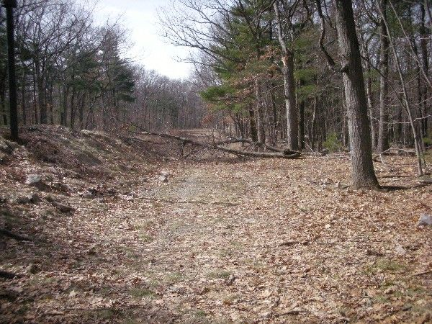
GDP2:
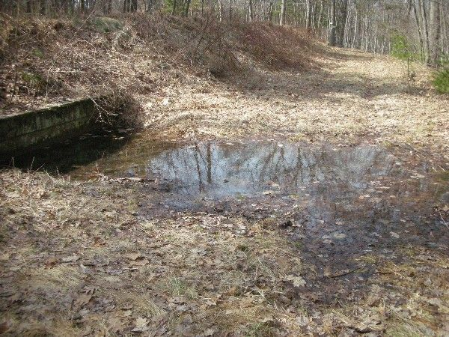

Abbreviations:

Usage type: foot traffic only (H), multi-use (M)

waterbars (wb) small blowdowns (sbd)
culverts(cv) large blowdowns (lbd)
rolling dips (rd) rock work (rkw)
bridges (br) bridge building (bbd),
bog bridges (bb) culvert replacement (cr)
rock stairs (rs) trail relocation (tr),
cribbing (cb) building new trail drainage (ntd)
retaining walls (rw) brushing needed (bn)
ditches (dt) excessive erosion (ee)
leaning tree (lt)

