TRAIL ASSESSMENT FORM

Doc. # | 4006 | Trail Name |  |  | Fox Hill Path North | Trail Type: |  | Wide - M | Condition |  | Good
Route: |  |  | Chickatawbut Road – Indian Camp Path
Recent Weather: |  |  | Rain within last 24 hours. Sunny in the 30’s
TRAIL LANDMARKS |  |  | - Trailhead is located on the north side of Chickatawbut Road across from the east end of the Blue Hills Reservoir and .7 miles west of the Chickatawbut Road entry gate on Willard Street. Trail leaves 50 yards west of the pipeline at a granite marker labeled Fox Hill Path.  - Trail begins as a footpath as opposed to a wide path noted on the DCR map.  - Bn at entry into woods.  - Lbd across treadway at 250 feet. Chainsaw removal. (1) (see photo fhp1)  - Bd to left of treadway at 360 feet. Pull off treadway with 2 people.  - Bd crosses treadway at 450 feet. Cutback. Bow saw.  - Treadway opens up to road width at .1 miles ascending Fox Hill.  - Bn at .13. Downed limbs. Bow Saw.  - Bn at .14. Downed limbs. Loppers.  - Bn at .19. Downed limbs. Loppers.  - Treadway crosses the summit of Fox Hill at .22 miles with lunch rock and cairn to the right of the treadway.  - Unnamed path leaves on the left at .24 miles. Old FBH maps show intersection marker 4096 at this point.  - Bn from .24 through .28 miles. Overhead and side bn.  - Bn at .30 through .31 miles.  - Trail begins descending Fox Hill steeply at .32 miles with nice view of Boston.  - Log wb at .37 miles. Needs to be dug out and dt on right.  - Three log wb at .38 miles. First two R to L and last L to R. Need to be dug out and dt.  - Rkw wb at .43 miles. R to L. Section of minor erosion follows. Wb is not effective and needs to be dug out and dt on left. (2)  - Rkw wb at .44 miles. L to R. Section of minor erosion follows. Wb is not effective and needs to be dug out and dt on right. (3)  - Fox Hill Path ends with its intersection with the Indian Camp Path at .47 miles.
MINOR  PROBLEM  AREAS |  |  | - Lbd across treadway at 250 feet. Chainsaw removal. (1) (See photo fhp1) Impairs fire road access.  - Rkw wb at .43 miles. R to L. Section of minor erosion follows. Wb is not effective and needs to be dug out and dt on left. (2)  - Rkw wb at .44 miles. L to R. Section of minor erosion follows. Wb is not effective and needs to be dug out and dt on right. (3)
MAJOR  PROBLEM AREAS |  |  | - None noted
DISTANCES TO MAJOR INTERSECTIONS |  |  | - Chickatawbut Road to Indian Camp Path - .47 miles.
Report prepared by: |  |  |  | Ken Jones |  |  | Assessment date: |  |  | 3/13/2008

Fhp1:
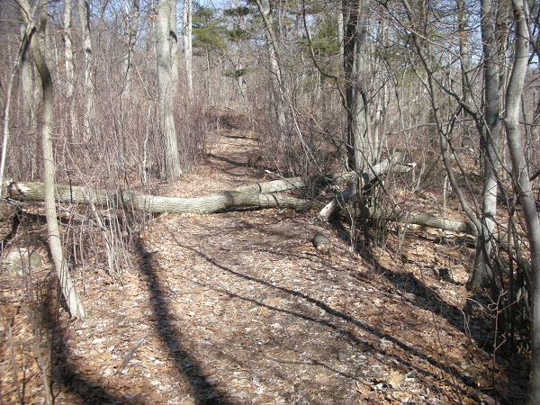

Abbreviations:

Usage type: foot traffic only (H), multi-use (M)

waterbars (wb) small blowdowns (sbd)
culverts(cv) large blowdowns (lbd)
rolling dips (rd) rock work (rkw)
bridges (br) bridge building (bbd),
bog bridges (bb) culvert replacement (cr)
rock stairs (rs) trail relocation (tr),
cribbing (cb) building new trail drainage (ntd)
retaining walls (rw) brushing needed (bn)
ditches (dt) excessive erosion (ee)
leaning tree (lt)

