TRAIL ASSESSMENT FORM

Doc. # | 4009 | Trail Name |  |  | Indian Camp Path West | Trail Type: |  | Wide - M | Condition |  | Good
Route: |  |  | Green Dot Loop – Wampatuck Road - 4155 – 4135 – 4120 – 4090 – 4083 Sawcut Notch Path
Recent Weather: |  |  | Rain last 24 hours, Light rain in the 30’s
TRAIL LANDMARKS |  |  | - For the purpose of this trail description, Indian Camp Path will be surveyed using both the DCR and FBH maps. There are some sections of this trail that do not appear on the DCR maps and I feel they should be included to extend this fine walk in the woods. The old FBH maps refer to this trail as the Indian Camp Trail.  - The trailhead is located .03 miles west of intersection marker 4202 on the south side of the southern section of the Green Dot Trail Loop. Trailhead is approximately .43 miles from the Shea Rink parking area. Intersection marker 4202 is a bootleg marker (magic marker) on a 4x4 wooden post and should be changed to a standard DCR marker. (1)  - Trail leaves this section of the Green Dot loop at blue diamond shaped wooden blaze nailed to a tree. This section of the trail uses this type of blazing until its intersection with Wampatuck Road. Old FBH maps note intersection marker 4215 at this point and it could not be found in the field. Treadway is not heavily traveled and leaves as a small footpath down from the pipeline and into the woods.  - Treadway goes around the right side of a large boulder and intersects a road width path at 75 feet with bn.  - Treadway then turns right (west) and parallels the Green Dot Trail through the woods.  - Bn at 190 feet.  - Unnamed path leaves on right at 230 feet.  - Bn at 300feet.  - Treadway opens to road width at 450 feet.  - Bn at .12 miles.  - Bd crosses treadway at .16 miles and should be removed. Bow saw.  - Treadway narrows to a footpath at .2 miles.  - Rkw wb at .24 miles. L to R. Needs to be dug out and dt on the right.  - Unnamed path leaves on the right at .29 miles to Wampatuck Road.  - Lbd crosses the treadway at .31 miles. Could be cut back if desired. Chainsaw removal.  - Downed limb crosses at .32 miles. Bow saw and loppers.  - Trail crosses Wampatuck Road at the guardrail and two boulders at .32 miles. No FBH intersection marker 4171 noted.  - Treadway renters the woods beyond guardrail and intersects the pipeline and the southern section of the Greed Dot Trail Loop at .35 miles. At this point the Indian Camp Path and the Green Dot Loop utilize the same treadway.  - Treadway continues at fire road width and continues to parallel the pipeline.  - Sbd across the treadway at .50 miles. 4”. Bow saw.  - Cv to the left of the treadway at .51 miles under pipeline. Cement construction with 2 pipes half full of debris. Water not draining and treadway has 2’ of water on it. Needs to be dt into woods on right. (2) (see photo gd1)  - Skyline crosses at intersection marker 4155 at .56 miles. Signage on tree denotes Skyline West to Great Blue Hill and Green Dot to St. Moritz Ponds.  - Lbd across treadway at .59 miles. 8” dia. Chainsaw. Blocking Fire road. (3) (See photo gd2)  - Cv to the left of the treadway at .62 miles under pipeline. Cement construction with 2 pipes half full of debris. Water not draining and treadway has 2’ of water on it. Needs to be dt into woods on right.  - Fire road partially blocked by new tree growth at .64 miles. Cut back.  - Cv to the left of the treadway at .70 miles under pipeline. Cement construction with 2 pipes half full of debris. Water not draining and treadway has 2’ of water on it. Needs to be dt into woods on right.  - Bn at .71 miles.  - Unnamed path leaves on left at .72 miles.  - Cv under treadway at .73 miles. Cement work to right of treadway.  - Cv to the left of the treadway at .75 miles under pipeline. Cement construction totally impacted. Treadway has 2’ of water on it. Needs to be dt into woods on right.  - Pipeline Trail (Crags Trail (FBH) crosses at intersection marker 4135 at .76 miles.  - Bn at .78 miles. Lopper work.  - Bn needed .87 through .93 miles.  - Cv under treadway in streambed at .96 miles. 24” clay pipe. Debris in rkw well on R and L to be cleaned.  - Unnamed path leaves on right at intersection marker 4120 at .97 miles. Road width connector to Crags Foot Path. Old FBH maps show this as the Furnace Brook Trail.  - Bn from .98 to 1.30miles. Small trees extending into treadway.  - Very minor erosion ascending hill at 1.09 miles.  - Unnamed path enters on left at 1.23 miles. Road width path to Fox Hill.  - Two inches of standing water in treadway at 1.24 miles  - Unnamed path leaves on left at 1.32 miles. Great Dome Foot Path as noted on old FBH maps.  - Treadway enters an intersection at intersection marker 4090 at 1.34 miles. Signage on tree denotes the Green Dot trail leaving on a footpath to the right (northeast). Indian Camp Path continues straight (northwest) at road width to intersection marker 4083 as noted on old FBH maps. Pleasant Trail (FBH) leaves on the left at road width to intersection marker 4043 as noted on old FBH maps.  - Bn 1.37 through 1.39 miles.  - Unnamed path enters on the left at 1.40. Spur path to intersection marker 4043. ( Pleasant Trail FBH map)  - Cv under treadway in streambed running R to L at 1.40 miles. Rkw on R an L w/ 18” corrugated PVC pipe. Rkw wells require cleaning.  - Bn at 1.41 miles.  - Bn at 1.44 miles.  - Unnamed path leaves on right at 1.46 miles to intersection marker 4091.  - Bn at 1.47 miles.  - Crags Foot Path enters on right at 1.48 miles.  - Lbd crosses treadway at 1.5 miles. Chainsaw removal (8-12”) as this is a fire road. (4)  - Indian Camp Path ends with its intersection with Sawcut Notch Path at intersection marker 4083 at 1.57 miles.
MINOR  PROBLEM  AREAS |  |  | - Intersection marker 4202 is a bootleg marker (magic marker) on a 4x4 wooden post and should be changed to a standard DCR marker. (1)  - Cv to the left of the treadway at .51 miles under pipeline. Cement construction with 2 pipes half full of debris. Water not draining and treadway has 2’ of water on it. Needs to be dt into woods on right. (2) (see photo gd1)  - Lbd across treadway at .59 miles. 8” dia. Chainsaw. Blocking Fire road. (3) (See photo gd2)  - Lbd crosses treadway at 1.5 miles. Chainsaw removal (8-12”) as this is a fire road. (4)
MAJOR  PROBLEM AREAS |  |  | - None noted
DISTANCES TO MAJOR INTERSECTIONS |  |  | - Green Dot Loop to Wampatuck Road - .32 miles.  - Green Dot Loop to Skyline Trail at intersection marker 4155 - .56 miles.  - Green Dot Loop to Crags Trail (FBH) at intersection marker 4135 - .76 miles.  - Green Dot Loop to Furnace Brook Trail (FBH) leaves on right at intersection marker 4120 - .97 miles.  - Green Dot Loop to an intersection at intersection marker 4090 - 1.34 miles. Green Dot, Pleasant Trail and Indian Camp Path.  - Green Dot Loop to Indian Camp Path ends with its intersection with Sawcut Notch Path at intersection marker 4083 - 1.57 miles.
Report prepared by: |  |  |  | Ken Jones – 3/20/08 |  |  | Assessment date: |  |  | 3/7/2008

GDP1:
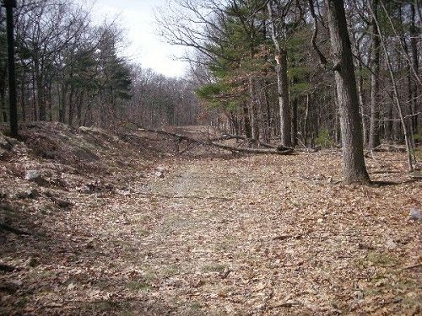
GDP2:
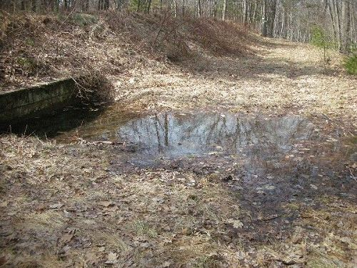

Abbreviations:

Usage type: foot traffic only (H), multi-use (M)

waterbars (wb) small blowdowns (sbd)
culverts(cv) large blowdowns (lbd)
rolling dips (rd) rock work (rkw)
bridges (br) bridge building (bbd),
bog bridges (bb) culvert replacement (cr)
rock stairs (rs) trail relocation (tr),
cribbing (cb) building new trail drainage (ntd)
retaining walls (rw) brushing needed (bn)
ditches (dt) excessive erosion (ee)
leaning tree (lt)

