TRAIL ASSESSMENT FORM

Doc. # | 4015 | Trail Name |  |  | Pasture Run North | Trail Type: |  | Wide - M | Condition |  | Good
Route: |  |  | Chickatawbut Road – 4030 – Headquarters Trail (FBH)
Recent Weather: |  |  | No rain last 48 hours, Sunny in the 30’s
TRAIL LANDMARKS |  |  | - Trailhead is located on the north side of Chickatawbut Road, .12 miles east of the Chickatawbut Outlook. There are two paths that leave Chickatawbut Road and access the main trail. For the purpose of this survey, mileage noted reflects the trailhead leaving from the westernmost path at 4 large boulders. The easternmost path (261 feet east), has 2 large boulders and a granite marker labeled Great Dome Trail. The Great Dome Trail (FBH) leaves this path immediately on the right.  - Bn immediately through 10 feet.  - Treadway descends at road width.  - Unnamed path enters on right at 180 feet. This is the spur path back to Chickatawbut Road noted above. Debris needs to be removed on it.  - Treadway continues to descend.  - Wooden wb at 230 feet. R to L. Dt on left. Rotted. Needs to be replaced at full treadway width and dt cleaned.  - Bn at 470 feet. Bow saw and loppers.  - Bn from .1 through .11 miles  - Sassaman Path (Trailhead) leaves on the right (north) at .15 miles. Pasture Run turns left (northwest).  - Large bd w/bn crosses treadway entering Pasture Run at this intersection. Chainsaw removal (1) See photo pr1.  - Bn at .16 miles. Overhead and side.  - Bn at .18 miles.  - Downed limbs in treadway at .2 miles. Bow saw and loppers.  - Bn at .21 miles to bring treadway to road width.  - Bn at .22, .24, .26 and .27 miles.  - Bd crosses treadway at .3 miles and needs to be cutback.  - Cv under the treadway in a streambed at .32 miles. Rkw/earthen construction w/ 2 12’clat pipes. Flowing well. Clean inlet.  - Downed limbs at .34 miles. Bow saw.  - Bn at .36 miles.  - Bn at .37 miles. Pine boughs and debris.  - Bn at .39 miles. Limbs and debris.  - Minor runoff in treadway at .41 miles through Headquarters Path intersection.  - Pasture Run enters Headquarters Path at intersection marker 4030 at .41 miles.  - Pasture Run re-enters the woods at .42 miles w/bn.  - Small rock wall to right of treadway.  - Pasture Run ends with its intersection with the Headquarters Trail (FBH map) at .44 miles.
MINOR  PROBLEM  AREAS |  |  | - Large bd w/bn crosses treadway entering Pasture Run at this intersection. Chainsaw removal. (1) See photo pr1.
MAJOR  PROBLEM AREAS |  |  | - None Noted
DISTANCES TO MAJOR INTERSECTIONS |  |  | - Chickatawbut Road to Sassaman Path (Trailhead) leaves on the right (north) - .15 miles.  - Chickatawbut Road to Headquarters Path at intersection marker 4030 - .41 miles.  - Chickatawbut Road to Pasture Run ends at its intersection with the Headquarters Trail (FBH map) - .44 miles.
Report prepared by: |  |  |  | Ken Jones – 3/24/08 |  |  | Assessment date: |  |  | 3/24/2008
PR1:
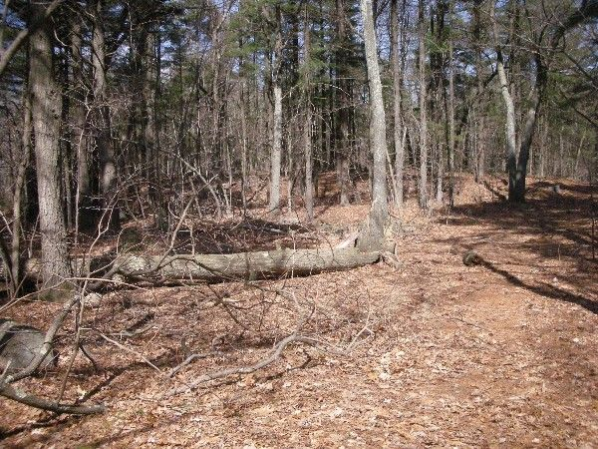
Abbreviations:

Usage type: foot traffic only (H), multi-use (M)

waterbars (wb) small blowdowns (sbd) leaning tree (lt)
culverts(cv) large blowdowns (lbd)
rolling dips (rd) rock work (rkw)
bridges (br) bridge building (bbd),
bog bridges (bb) culvert replacement (cr)
rock stairs (rs) trail relocation (tr),
cribbing (cb) building new trail drainage (ntd)
retaining walls (rw) brushing needed (bn)
ditches (dt) excessive erosion (ee)

