TRAIL ASSESSMENT FORM

Doc. # | 4019 | Trail Name |  |  | Short Path South | Trail Type: |  | Wide - M | Condition |  | Good
Route: |  |  | Sawcut Notch Path - Crags Foot Path
Recent Weather: |  |  | No rain last 24 hours – Partly cloudy in the 40s
TRAIL LANDMARKS |  |  | - Trailhead leaves from the south side on Sawcut Notch Path approximately .5 miles west of intersection marker 4180. Old FBH map intersection marker 4133 noted at the trailhead. Treadway is road width.  - Lbd crosses the treadway and Sawcut Notch Path at the trailhead 20’ w/bn. Chainsaw removal required. (1) see photo sp1  - Trail begins ascending at 315 feet.  - Trail begins descending at .1 miles and continues to end.  - Rkw cb to left and right of treadway from .15 through .17 miles.  - Cv under treadway at .17 miles. Rkw/earthen construction. Cleaning of dt and wells required (1)  - Short Path ends with its intersection with Crags Foot Path at .21 miles. . Old FBH map intersection marker 4124H noted at this trailhead.
MINOR  PROBLEM  AREAS |  |  | - Cv under treadway at .17 miles. Rkw/earthen construction. Cleaning of dt and wells required (1)  - Need a water bar just before the little triangular intersection. After a heavy rain there was a small pool to the left of the path and water was flowing down Short Path onto Sawcut. A bar would direct it to the area that we drained with the stone bar
MAJOR  PROBLEM AREAS |  |  | - None noted
DISTANCES TO MAJOR INTERSECTIONS |  |  | - Sawcut Notch Path to Crags Foot Path - .21 miles
Report prepared by: |  |  |  | Ken Jones 3/27/2008 |  |  | Assessment date: |  |  | 3/27/2008

SP1:

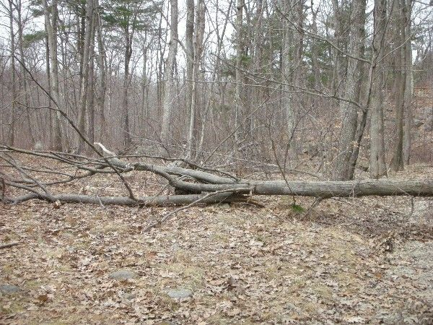

Abbreviations:

Usage type: foot traffic only (H), multi-use (M)

waterbars (wb) small blowdowns (sbd)
culverts(cv) large blowdowns (lbd)
rolling dips (rd) rock work (rkw)
bridges (br) bridge building (bbd),
bog bridges (bb) culvert replacement (cr)
rock stairs (rs) trail relocation (tr),
cribbing (cb) building new trail drainage (ntd)
retaining walls (rw) brushing needed (bn)
ditches (dt) excessive erosion (ee)
leaning tree (lt)

